**TUTORIAL FOR CREATION OF A JUMPBOX TO ACCESS ALL INSTANCES IN AWS**

The step-by step procedure to create a jumpbox in AWS is detailed below:

## **CREATION OF A VPC, A PUBLIC SUBNET AND A PRIVATE SUBNET**

1.1 **Creation of a VPC:**

* Login to <https://www.console.aws.amazon.com> >> Find services - search for VPC and click on **VPC**

# 

* Click on **Your VPCs** as shown below

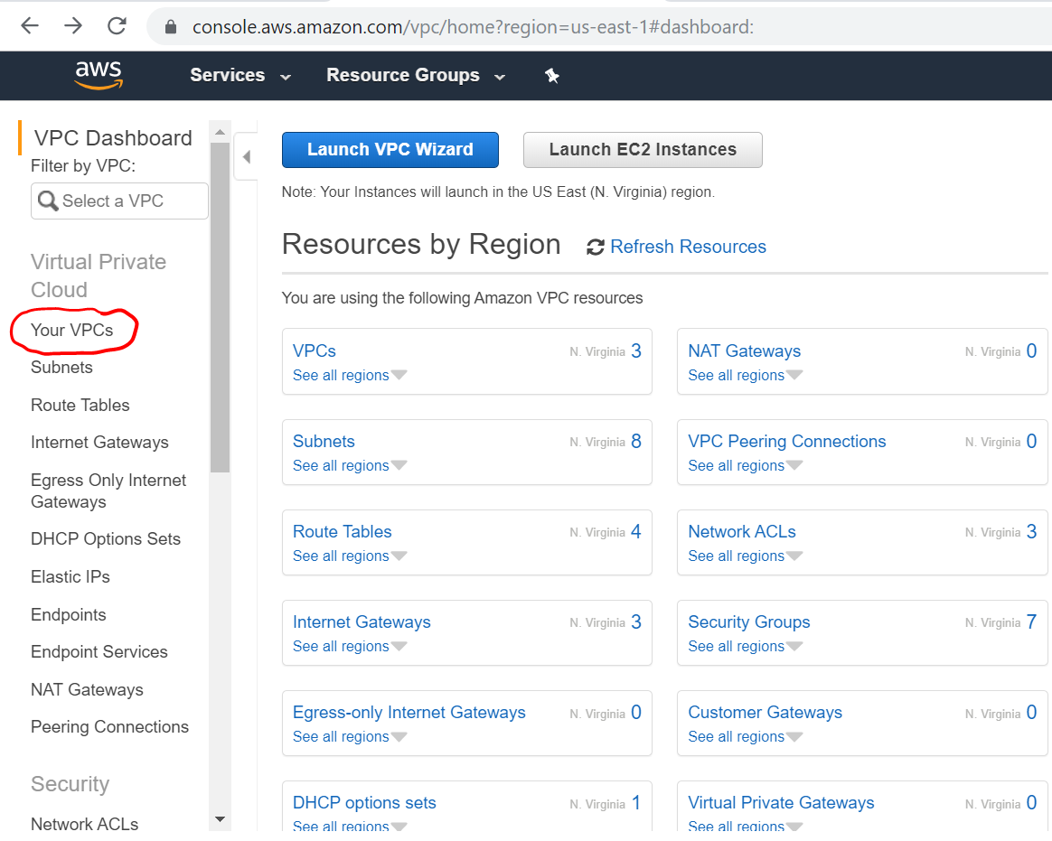

* Fill in the details in the **Name Tag** and **IPv4 CIDR Block** and click on **Create**

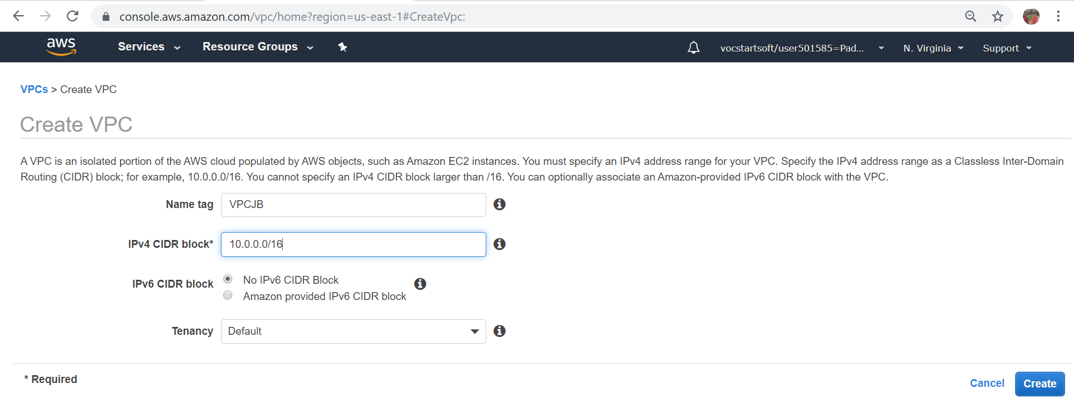

* **VPC** is created as shown below. Click on **Close**

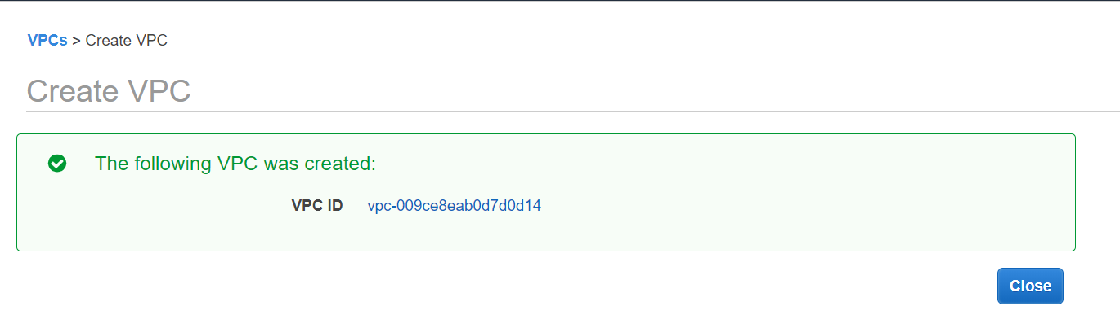

* 1. **Creation of a Public Subnet, Internet Gateway and Route table**
* In the **VPC Dashboard** click on **Subnets**

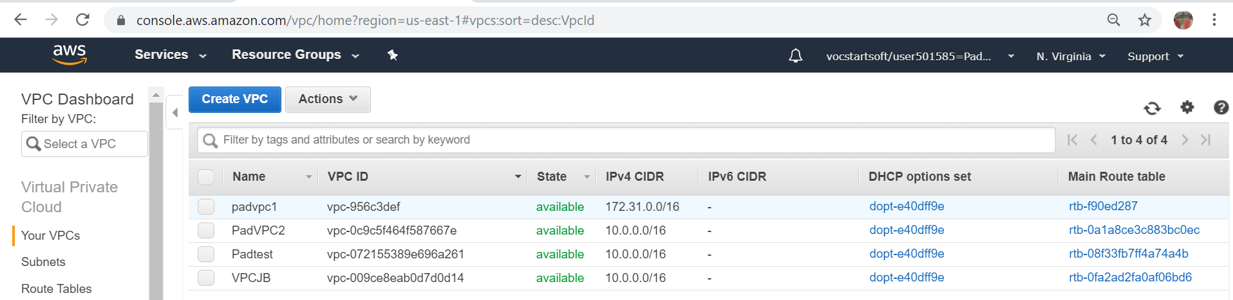

* In the subsequent screen click on **Create subnet**

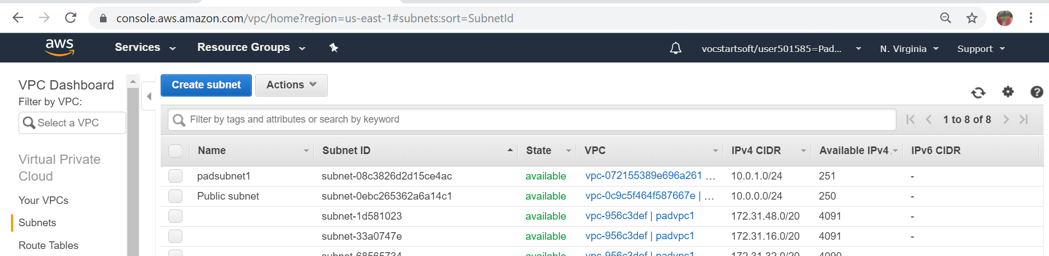

* **Name Tag**: Provide an appropriate name**; VPC**: Select the name from the dropdown menu

**IP4 CIDR block**: Type the appropriate address Eg. 10.0.0.0/24 >> Click on **Create**

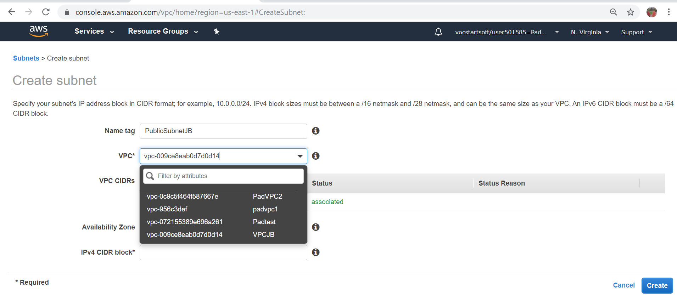

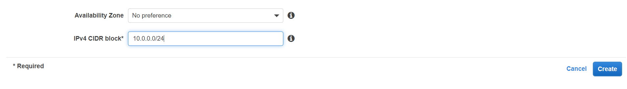

* A public subnet is created >> Click on **Close**

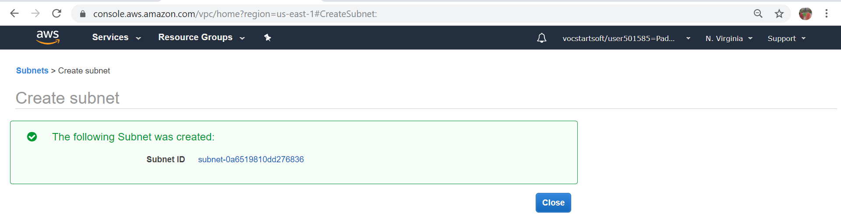

* In the VPC Dashboard **select the newly created Public Subnet**. Click on **Internet Gateways**

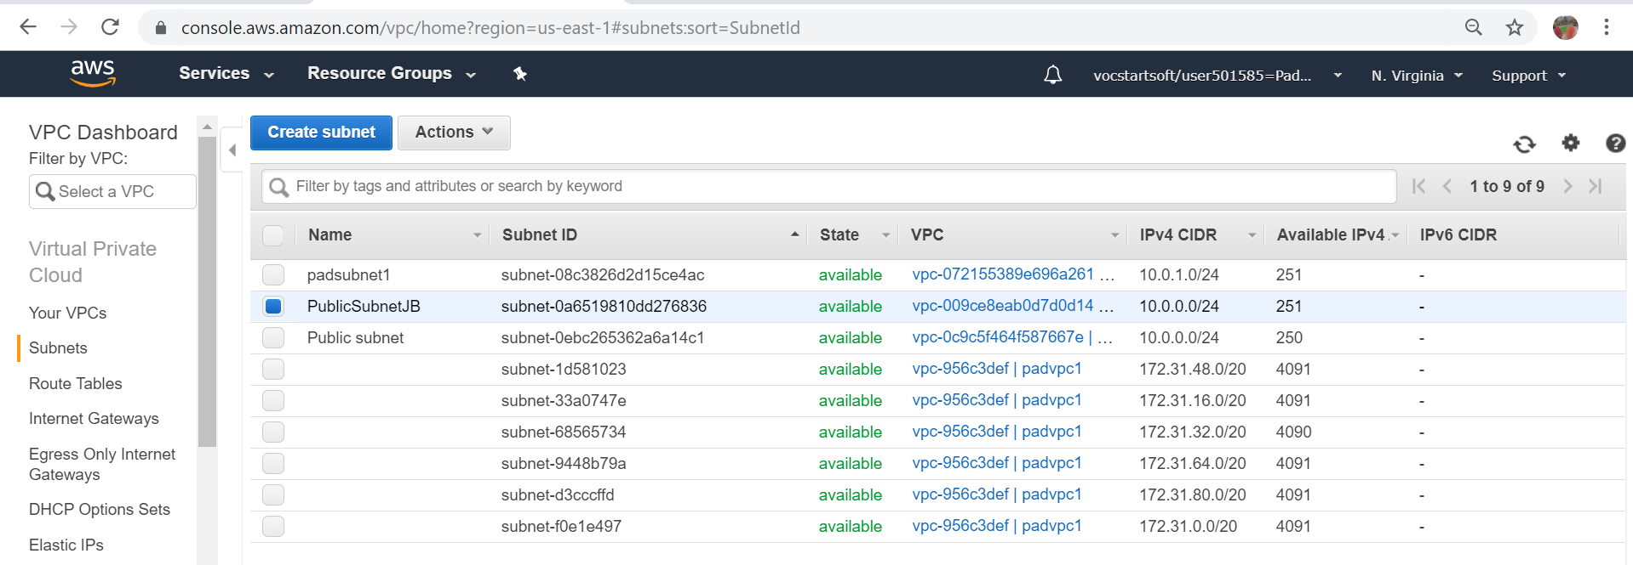

* **Name tag:** Provide a suitable name >> Click on **Create**

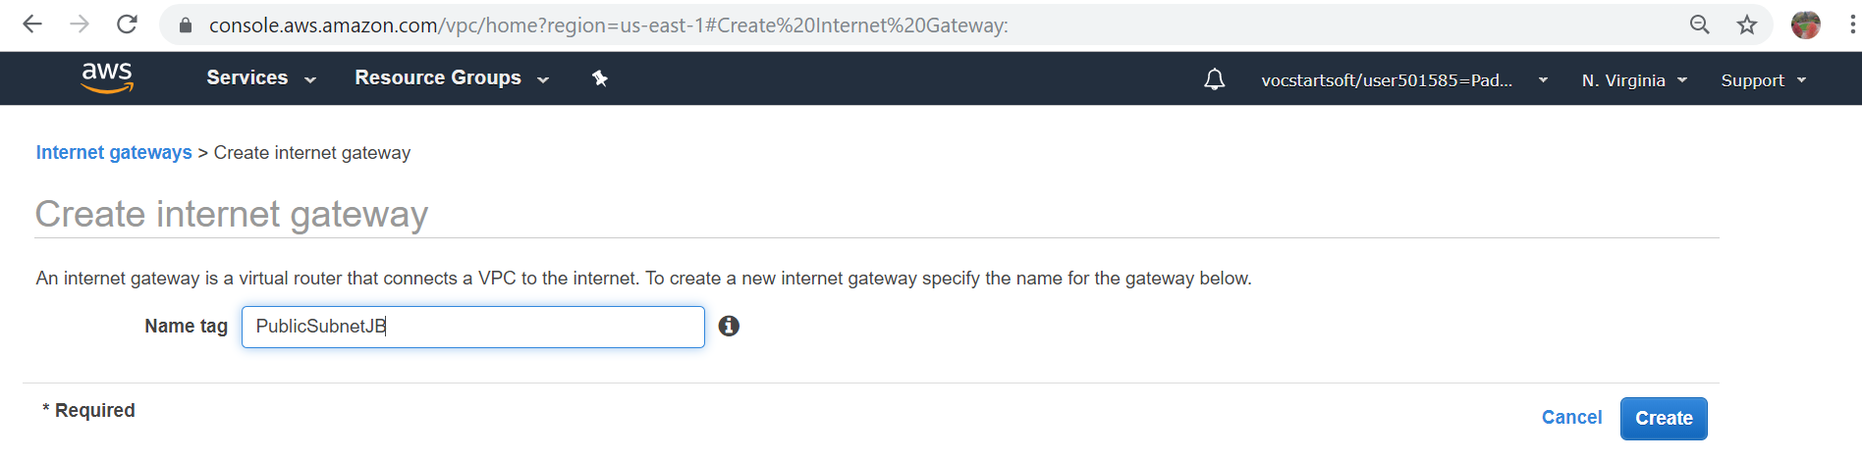

* An **Internet gateway is created** for the Public subnet >> Click on **Close**

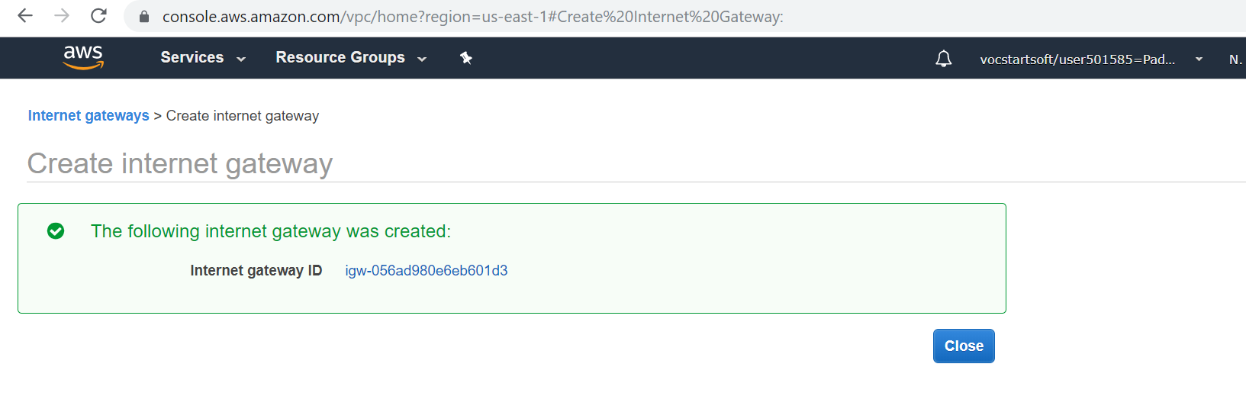

* **VPC Dashboard >> select** the **newly created Internet Gateway** >> **Actions** >> **Attach VPC**

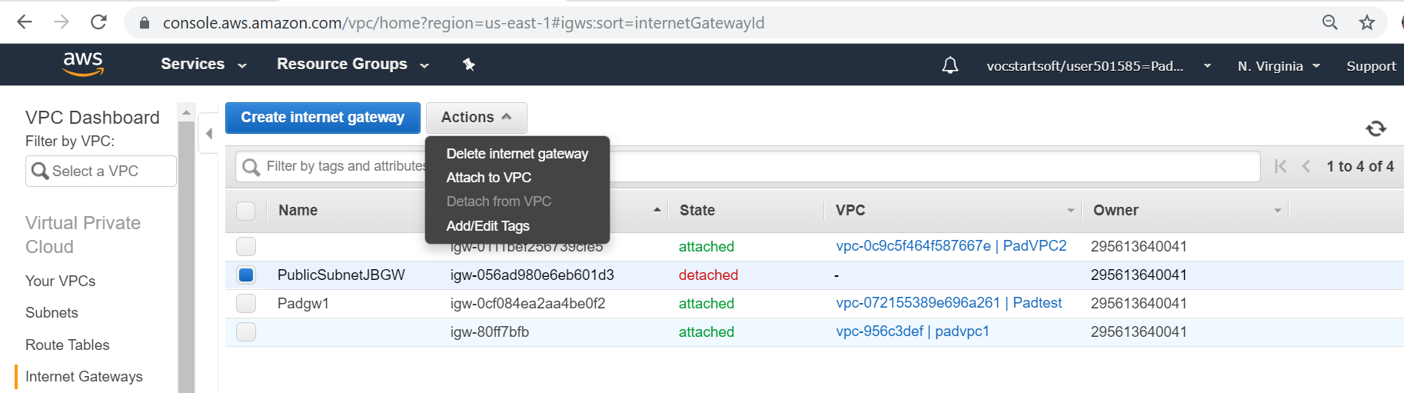

* **VPC** >> Click on the **dropdown menu** >> select the required **VPC ID** >> **Attach**

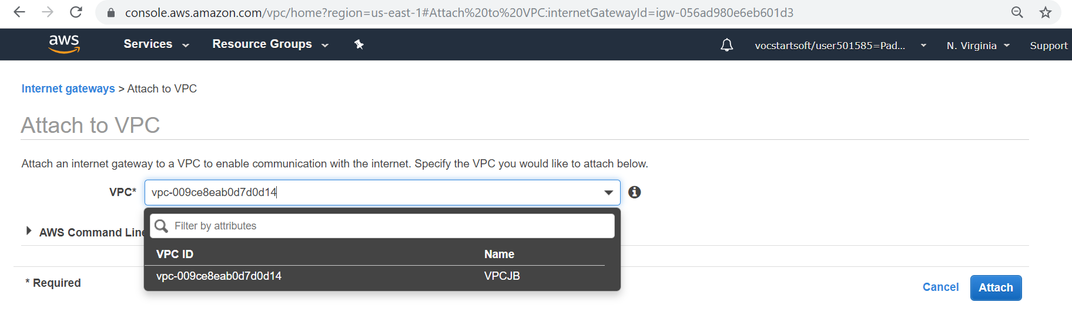

* The newly created **internet gateway is attached to the VPC**

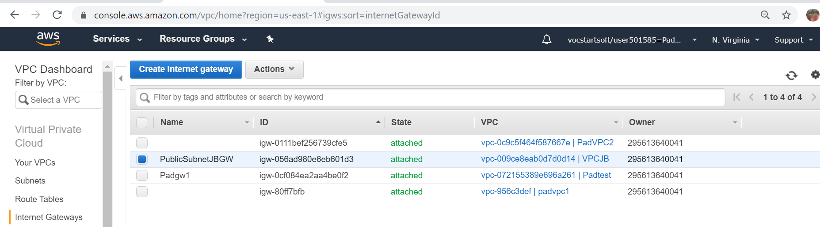

* In the **VPC Dashboard** click on **Route Tables** >> **Create route table**

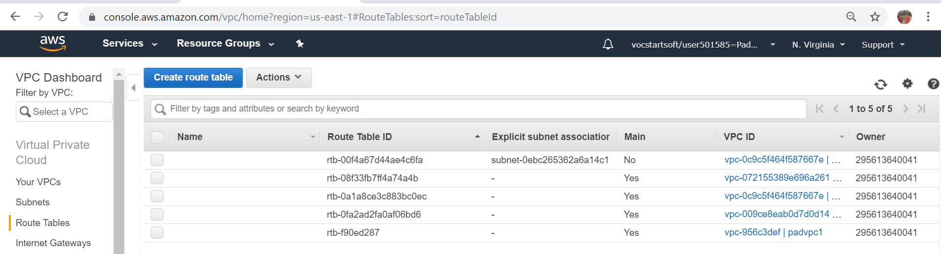

* **Name tag:** Provide a suitable name **VPC:** Select the relevant VPC from the dropdown menu

Click on **Create**

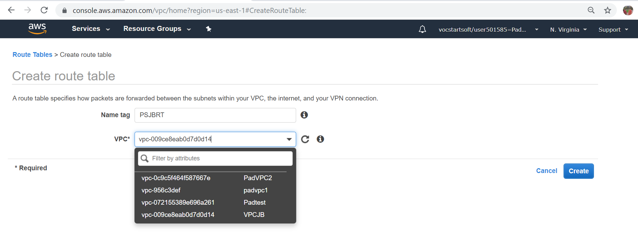

* A Route table is created. Click on **Close**

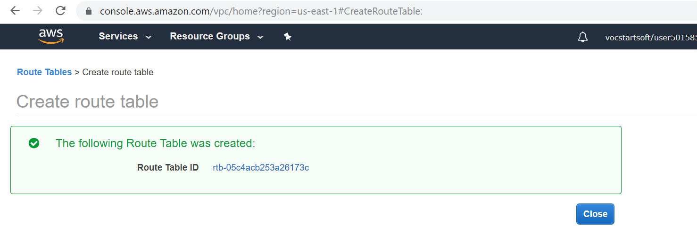

* **VPC Dashboard** >> **Route Tables** >> **Select the newly created route table**

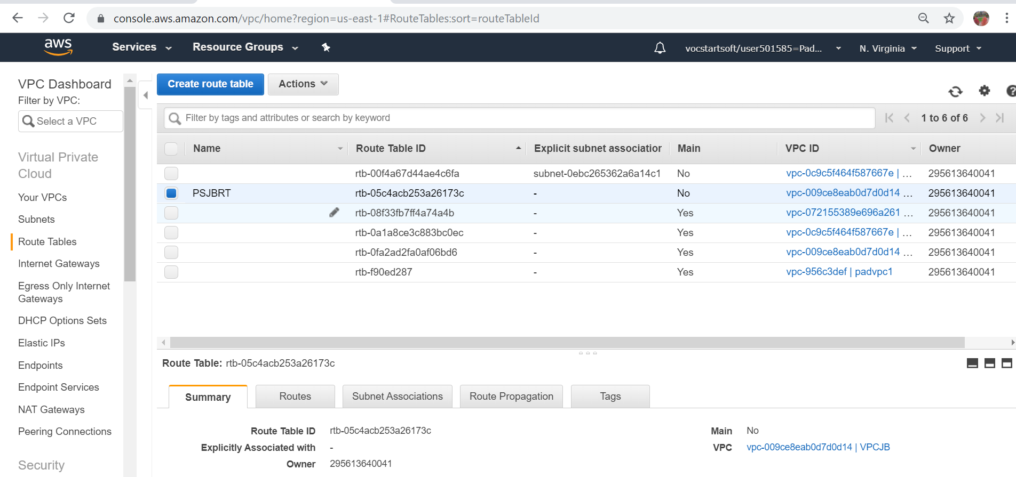

* Click on **Routes** >> **Edit routes**

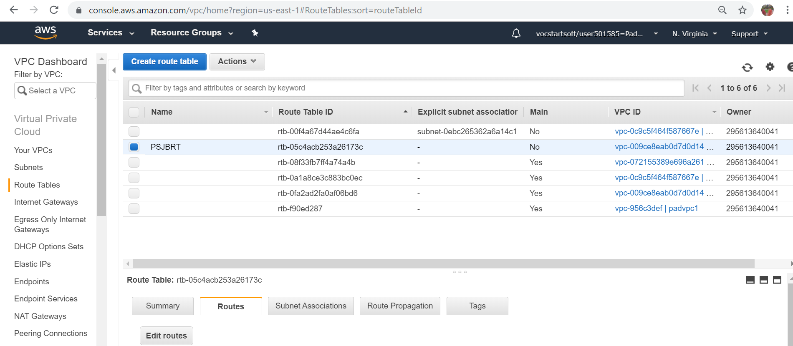

* Click on **Add route**

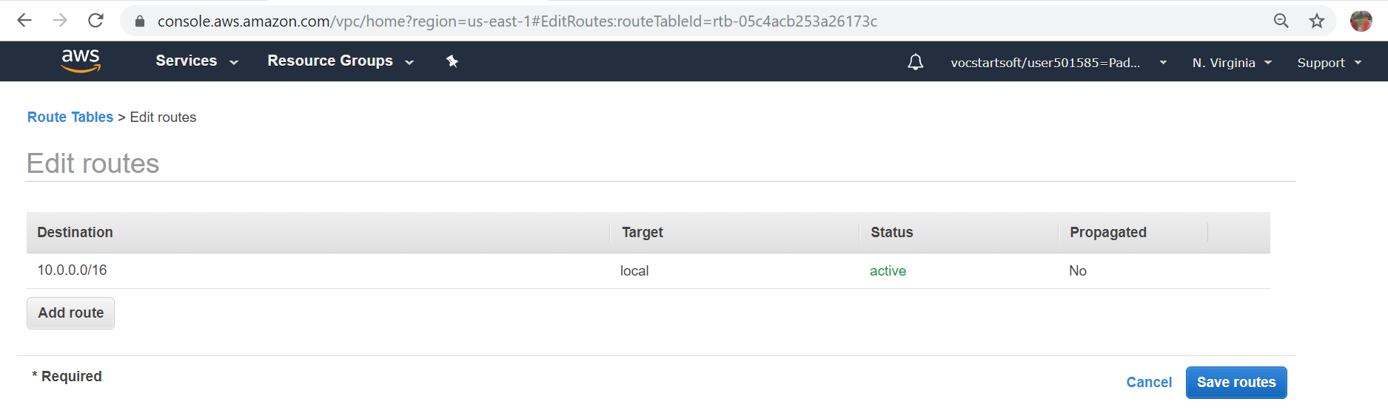

* **Destination:** Select **0.0.0.0/0** from the dropdown menu >> **Target:** New internet gateway from the dropdown menu >> Click on **Save routes**

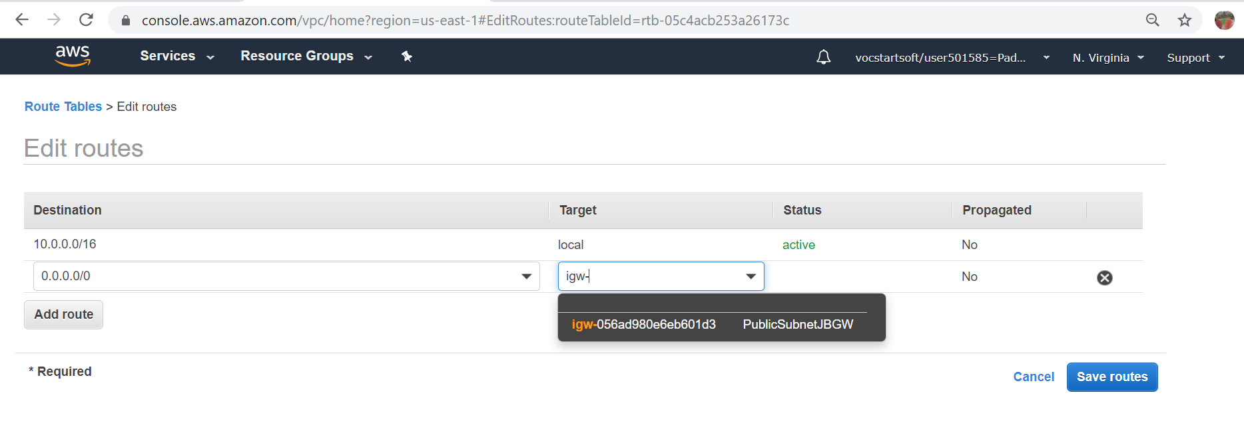

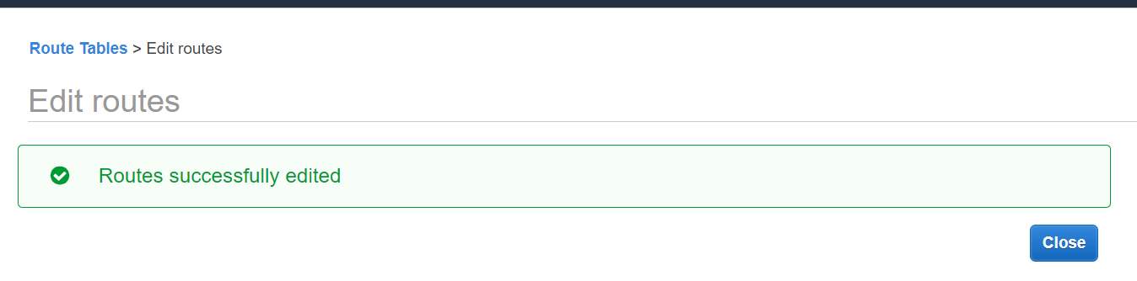

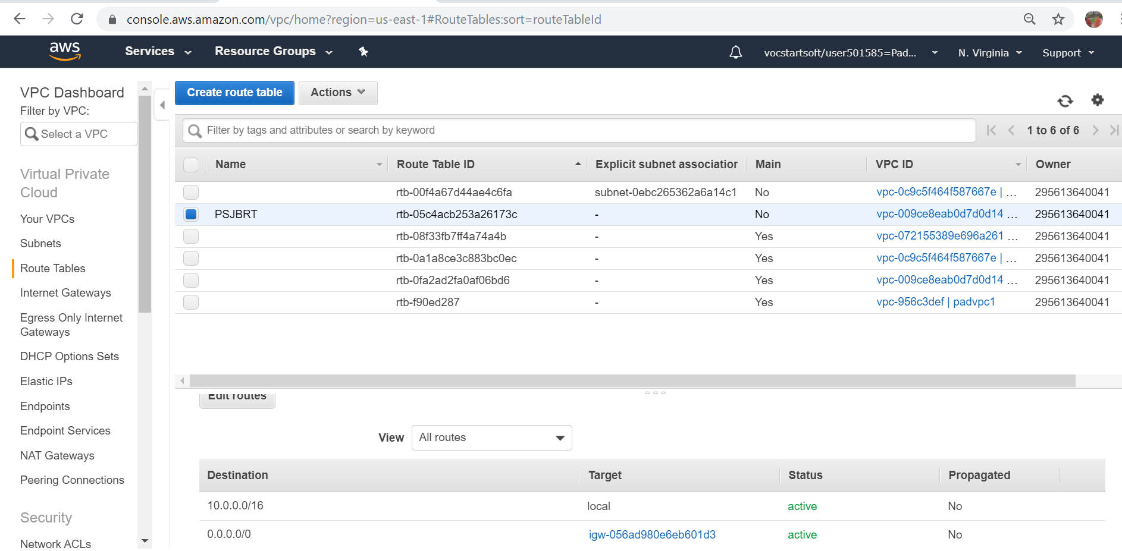

* Select the **new Route table** >> **Subnet Associations** >> **Edit subnet associations**

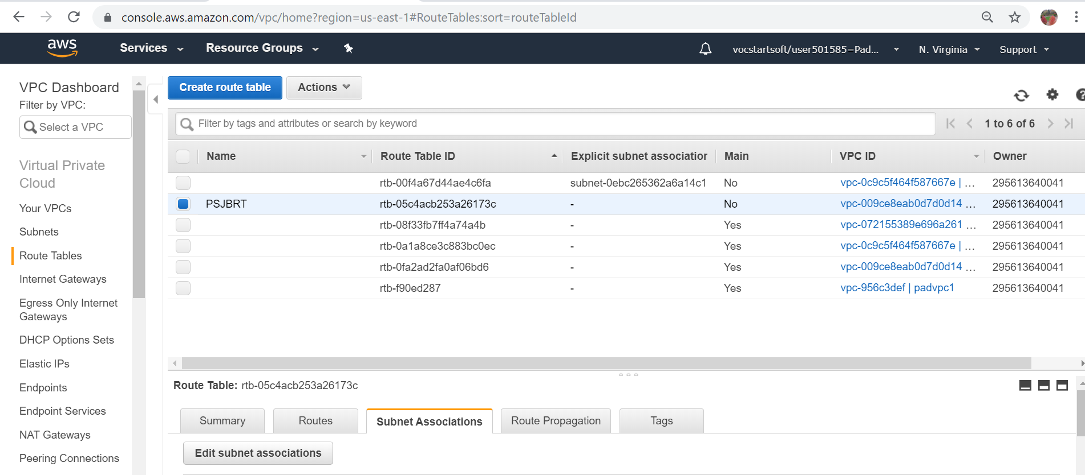

* Select the suitable **Public subnet** >> Click on **Save.** Subnet gets associated with the route table.

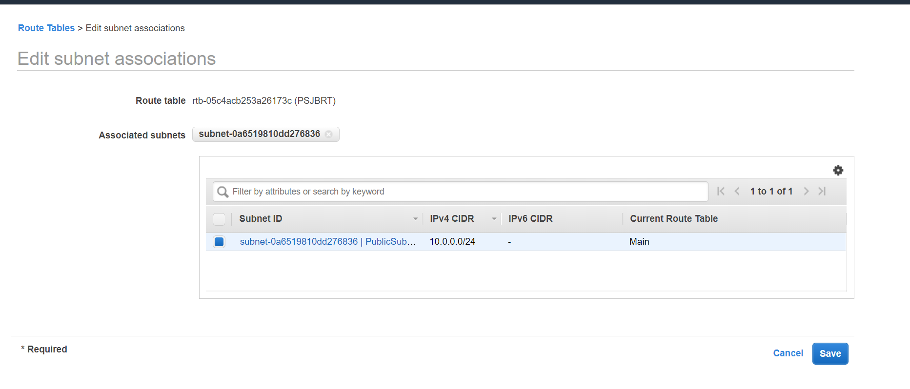

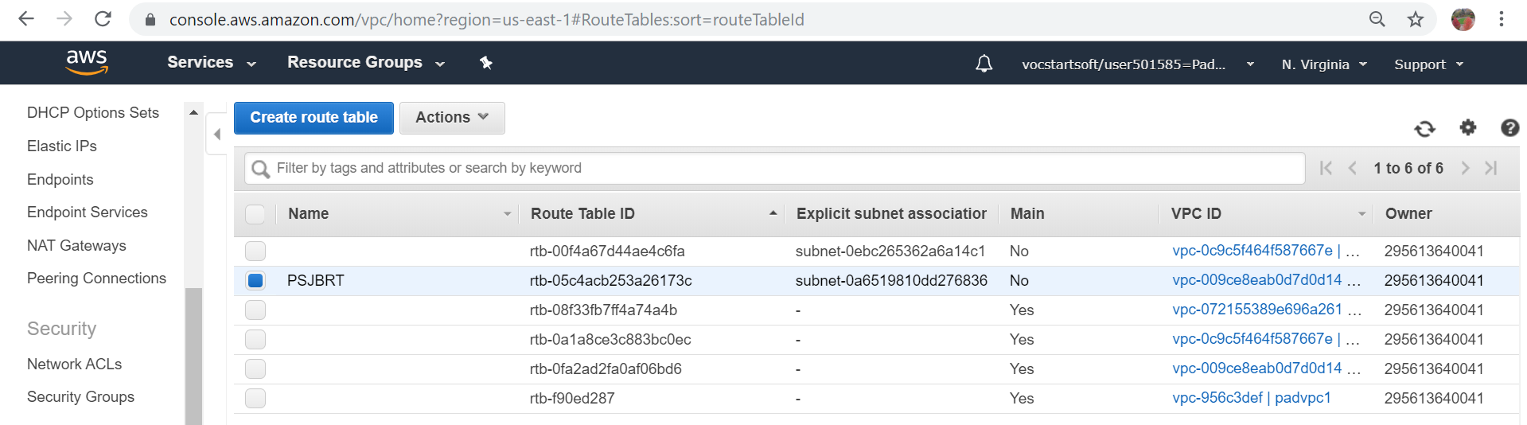

* 1. **Creation of a Private Subnet**
* In the **VPC Dashboard** click on **Subnets**



* In the subsequent screen click on **Create subnet**



**Name tag:** Provide a name suggesting that it is a Private subnet >> **VPC:** Select the VPC from the dropdown menu >> **IPv4 CIDR block:** Provide an address different from the Public IP Eg.10.0.1.0/24

>> **Create.** A private subnet is created. Click on **Close**

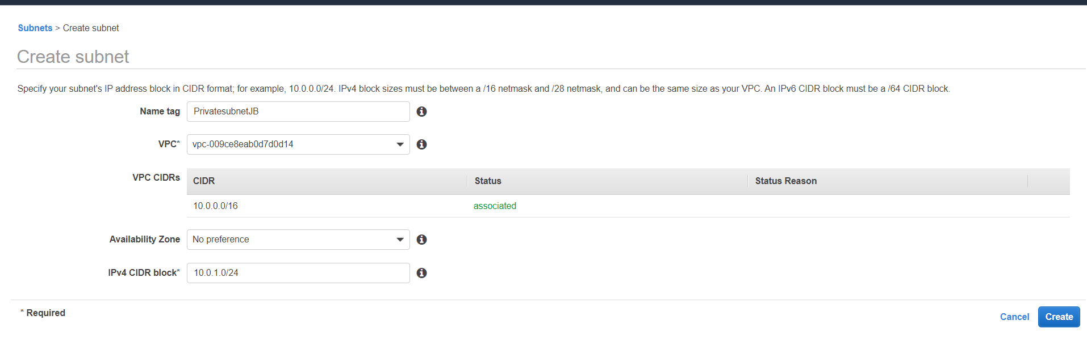

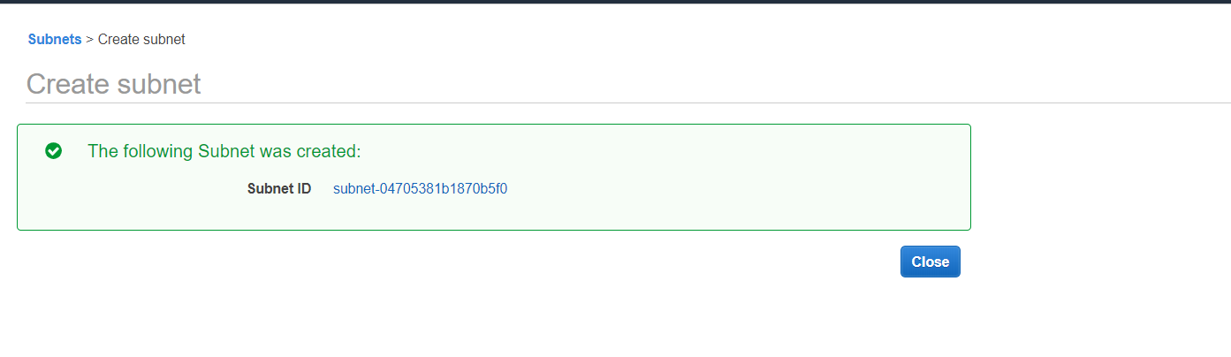

## **CREATION OF A NAT INSTANCE, JUMPBOX INSTANCE AND A FINAL INSTANCE**

* 1. **Creation of a NAT instance in the Public Subnet**
* **‘console.aws.com’** >> **Services** >> **EC2**

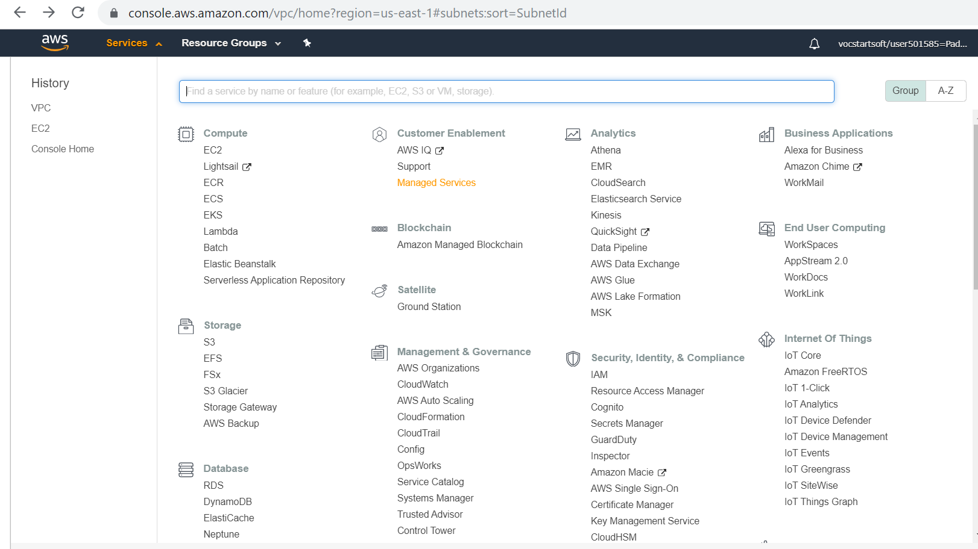

* Click on **Launch Instance**

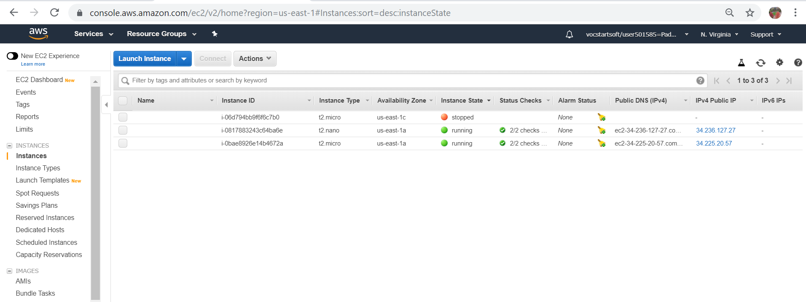

* In the search window enter **amzn-ami-vpc-nat**

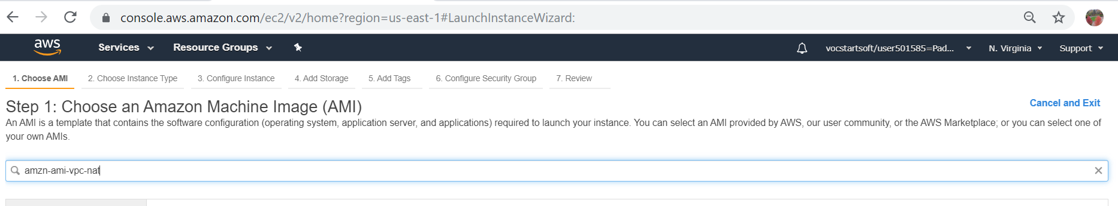

* **Community AMIs** >> **Select** the first item in the listing (this is the latest)

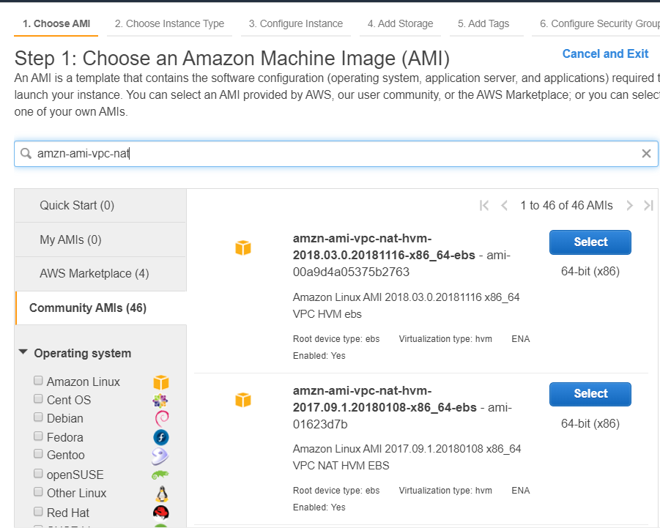

* Select the second instance type **t.micro** >> **Configure Instance Details**

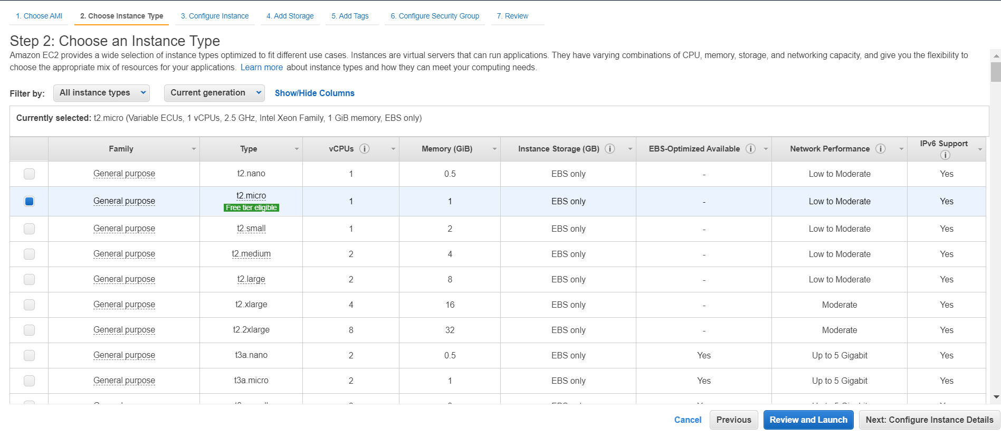

* **Network:** Select the correct VPC from the dropdown
* **Subnet:** Select the Public subnet from the dropdown
* **Auto-assign Public IP**: Enable >> Click on **Next:Add storage**

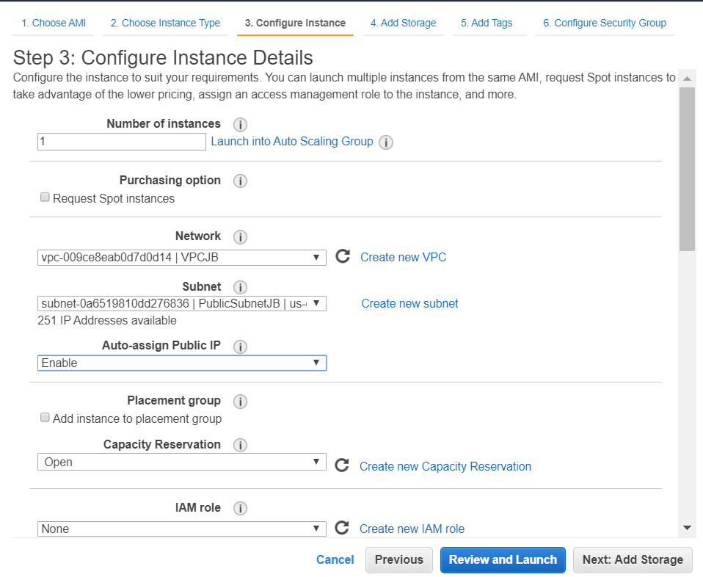

* Click on **Next: Add Tags**

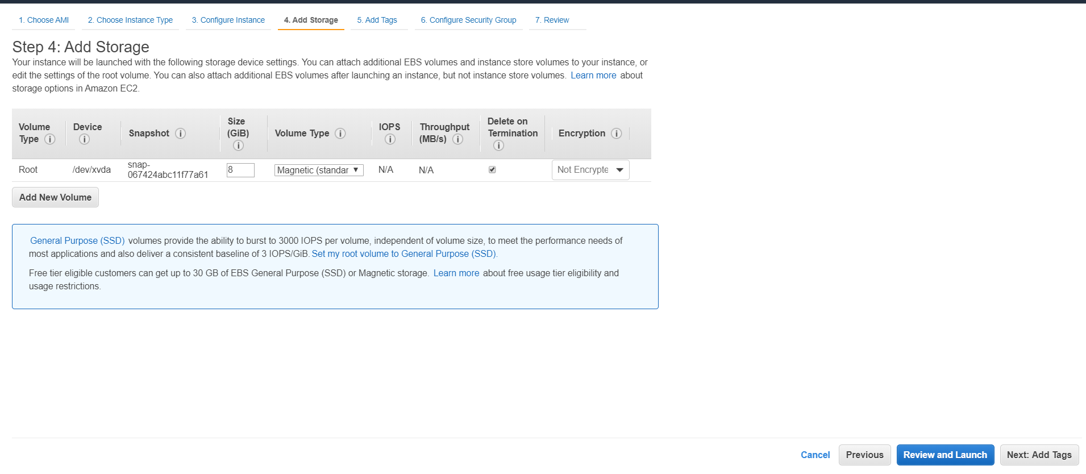

* Click on **Add Tag**

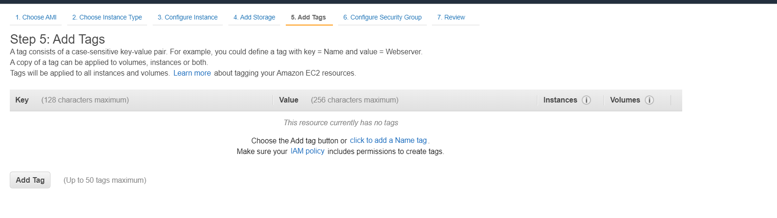

* **Key :** Name >> **Value:** Eg. NAT INSTANCE >> Click on **Next: Configure Security Group**

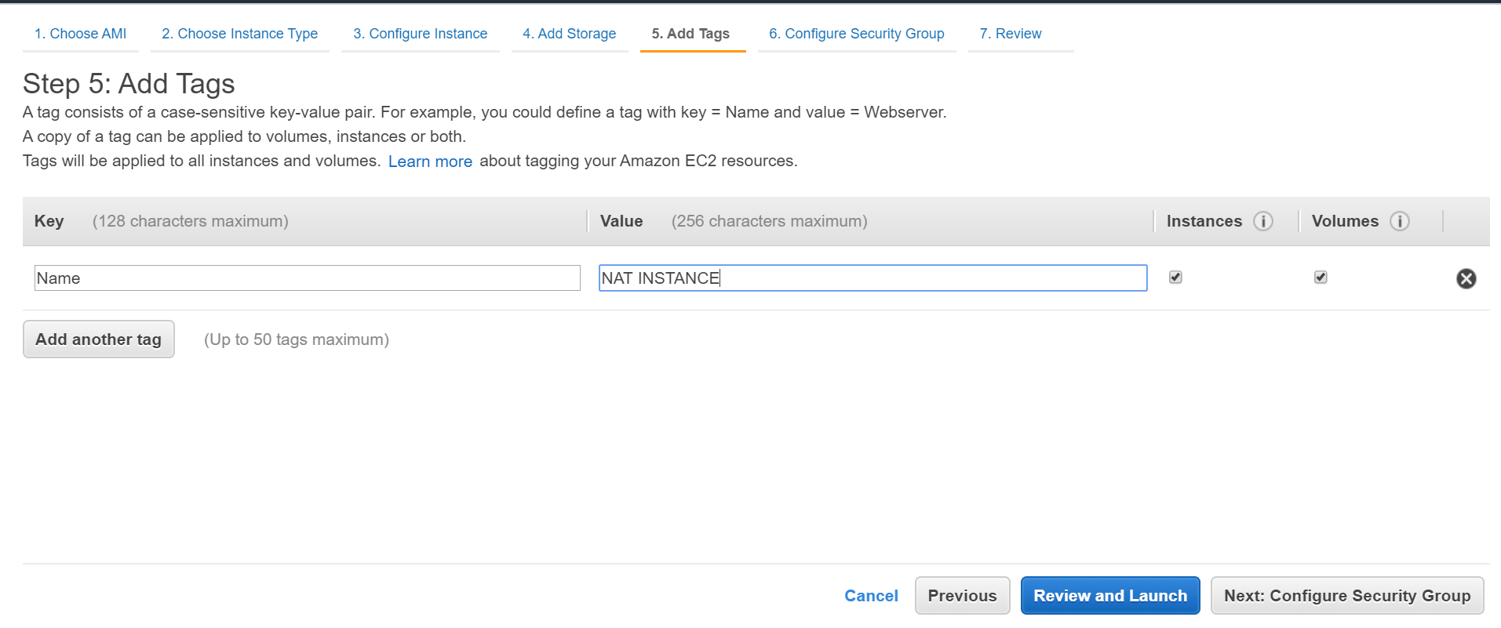

* Select **Create new security group >> Security group name:** Eg. NAT_SG >>
* **Description:** Eg. NAT_SG >> Click on **Review and Launch**

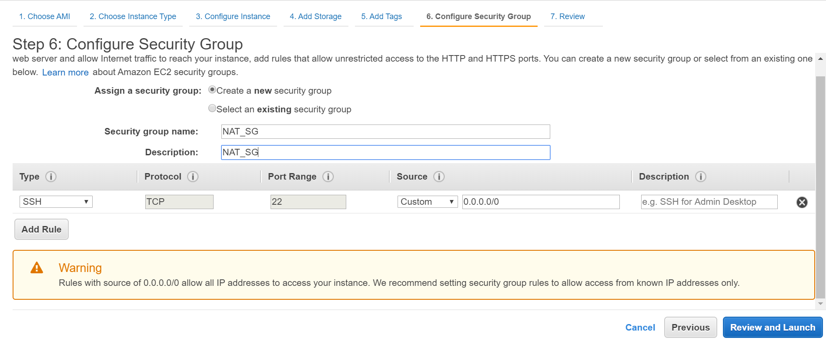

* Click on **Launch**

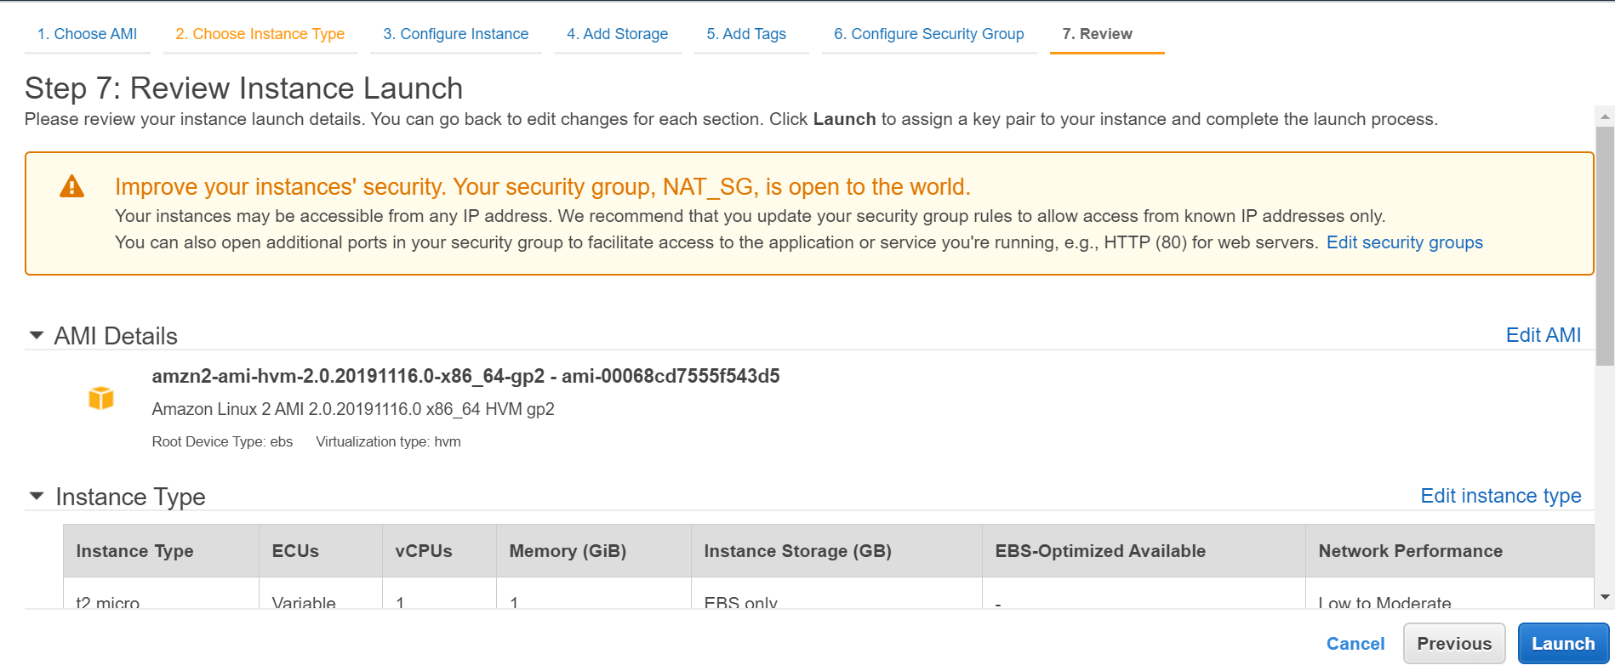

* **Choose an existing key pair** (or Create a new key pair using Putty Gen)
* If available, Select an existing key pair from the dropdown menu >> **Launch Instances**

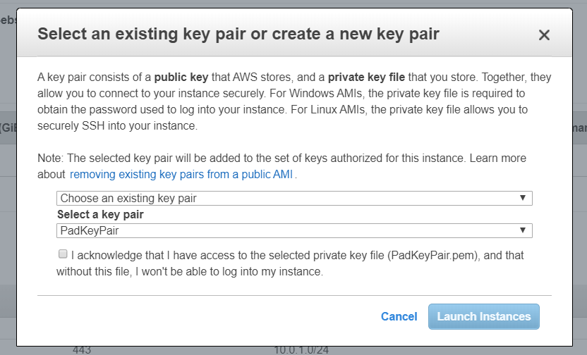

* A NAT instance has been created. Click on **View Instances**

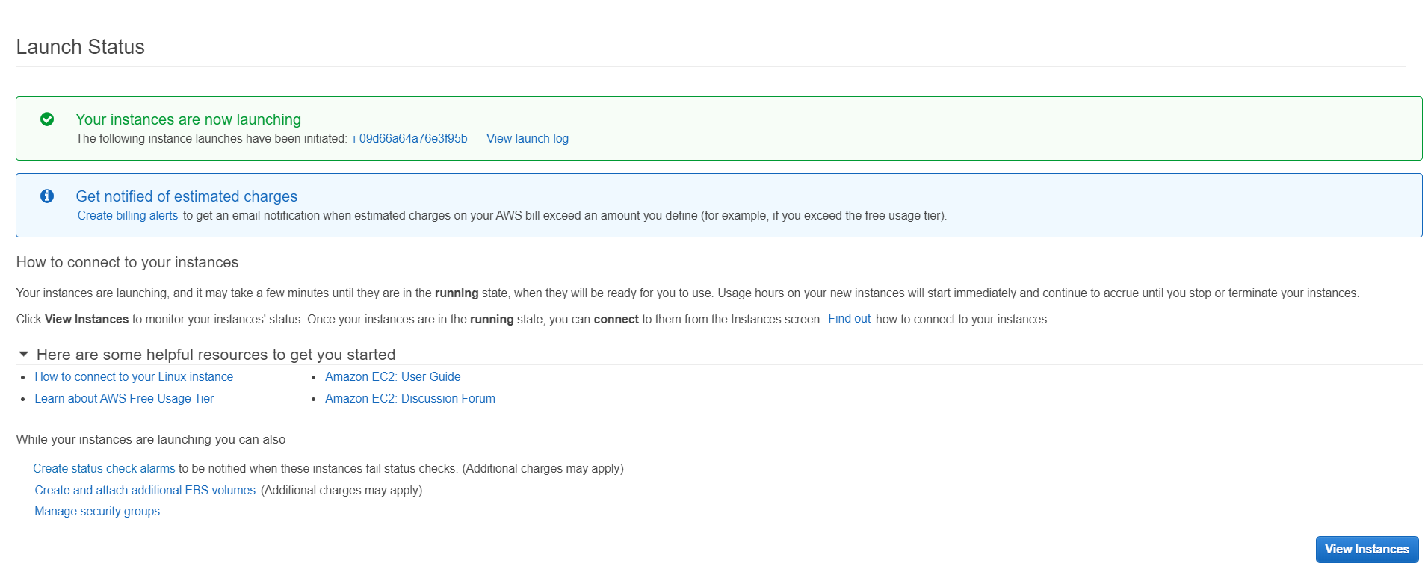

* 1. **Creation of a Jumpbox instance in the Public Subnet**
* **‘console.aws.com’** >> **Services** >> **EC2**



* Click on **Launch Instance**



* Select the first **Amazon Linux 2 AMI** instance

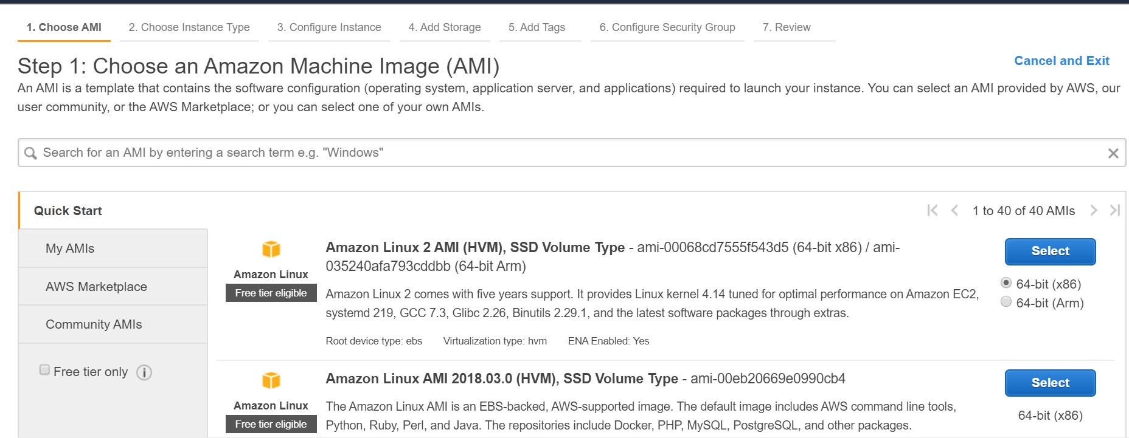

* Select the second instance type **t.micro** >> **Configure Instance Details**



* **Network:** Select the correct VPC from the dropdown
* **Subnet:** Select the Public subnet from the dropdown
* **Auto-assign Public IP**: Enable >> Click on **Next:Add storage**



* Click on **Next: Add Tags**



* Click on **Add Tag**



* **Key :** Name >> **Value:** Eg. JUMPBOX >> Click on **Next: Configure Security Group**

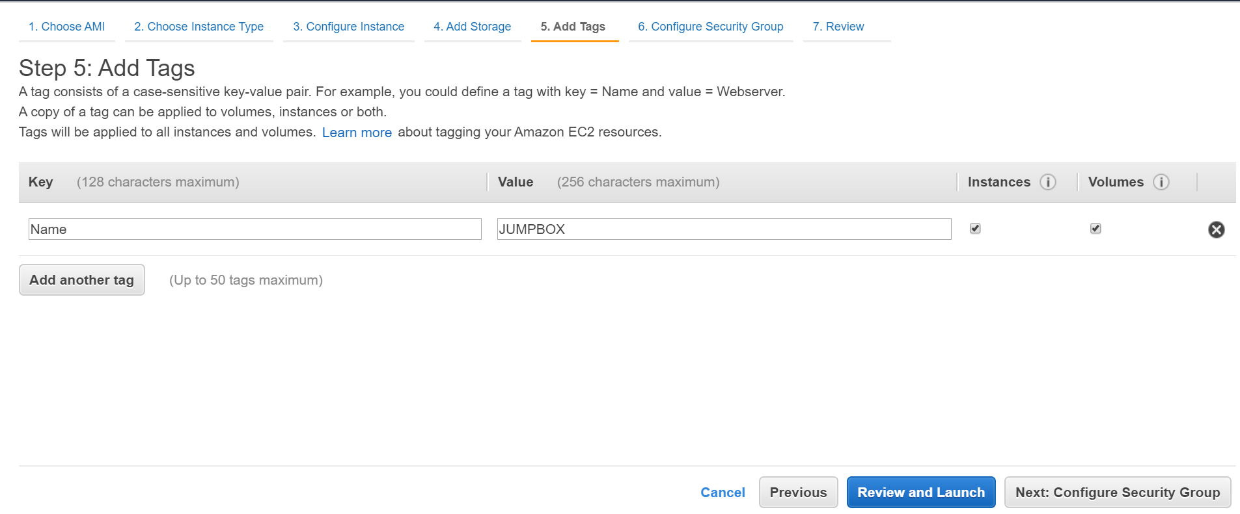

* Select **Create new security group >> Security group name:** Eg. JB_SG >>
* **Description:** Eg. JB_SG >> Click on **Review and Launch**

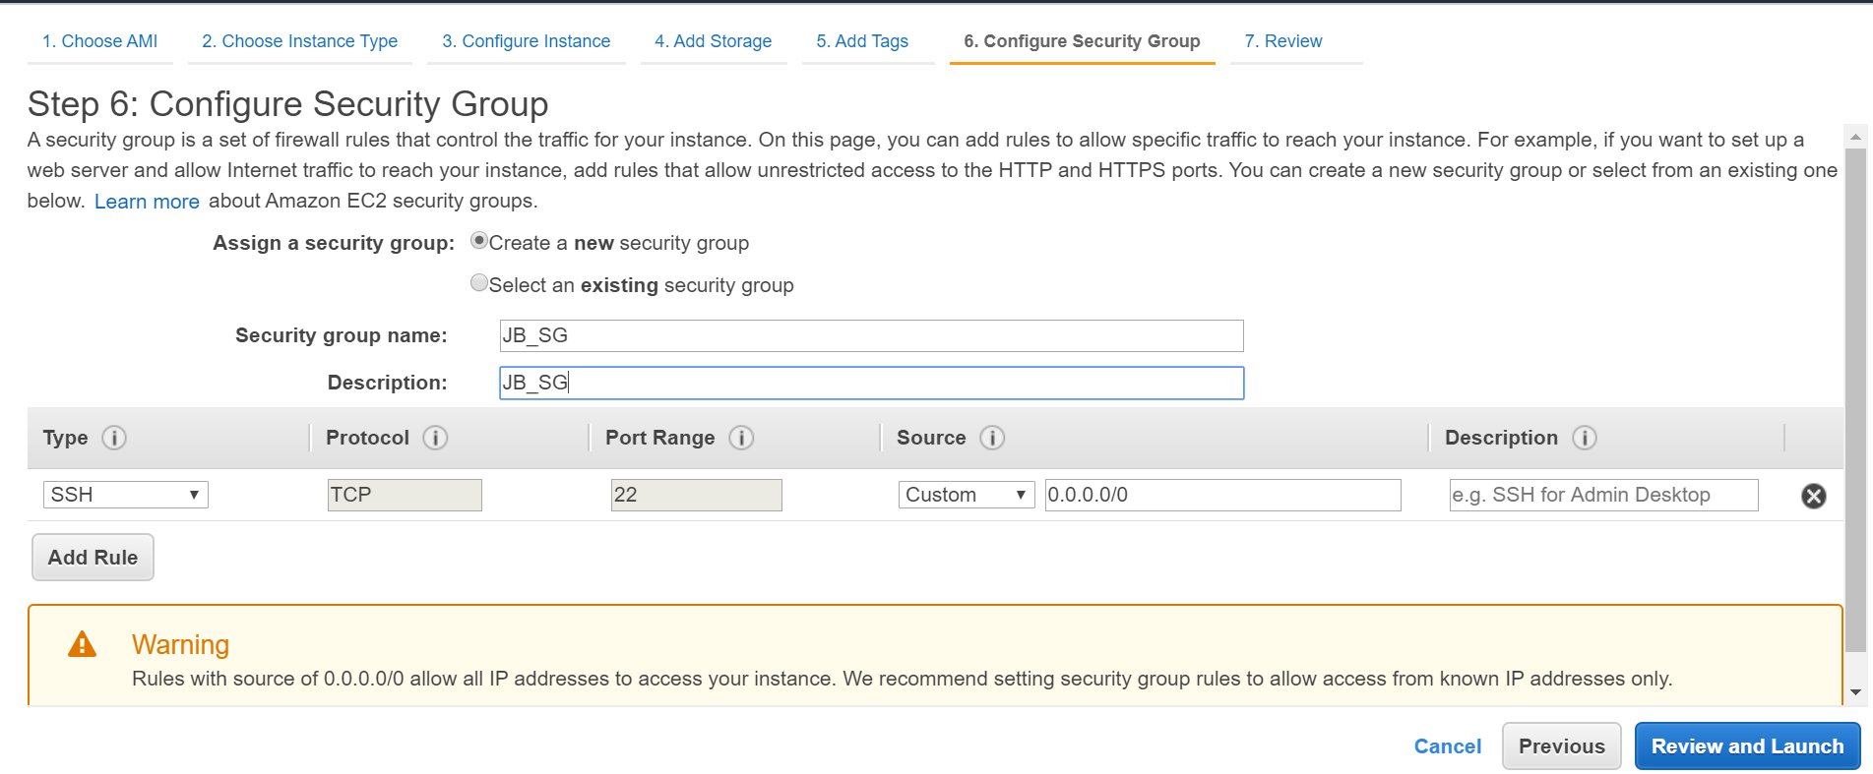

* Click on **Launch**

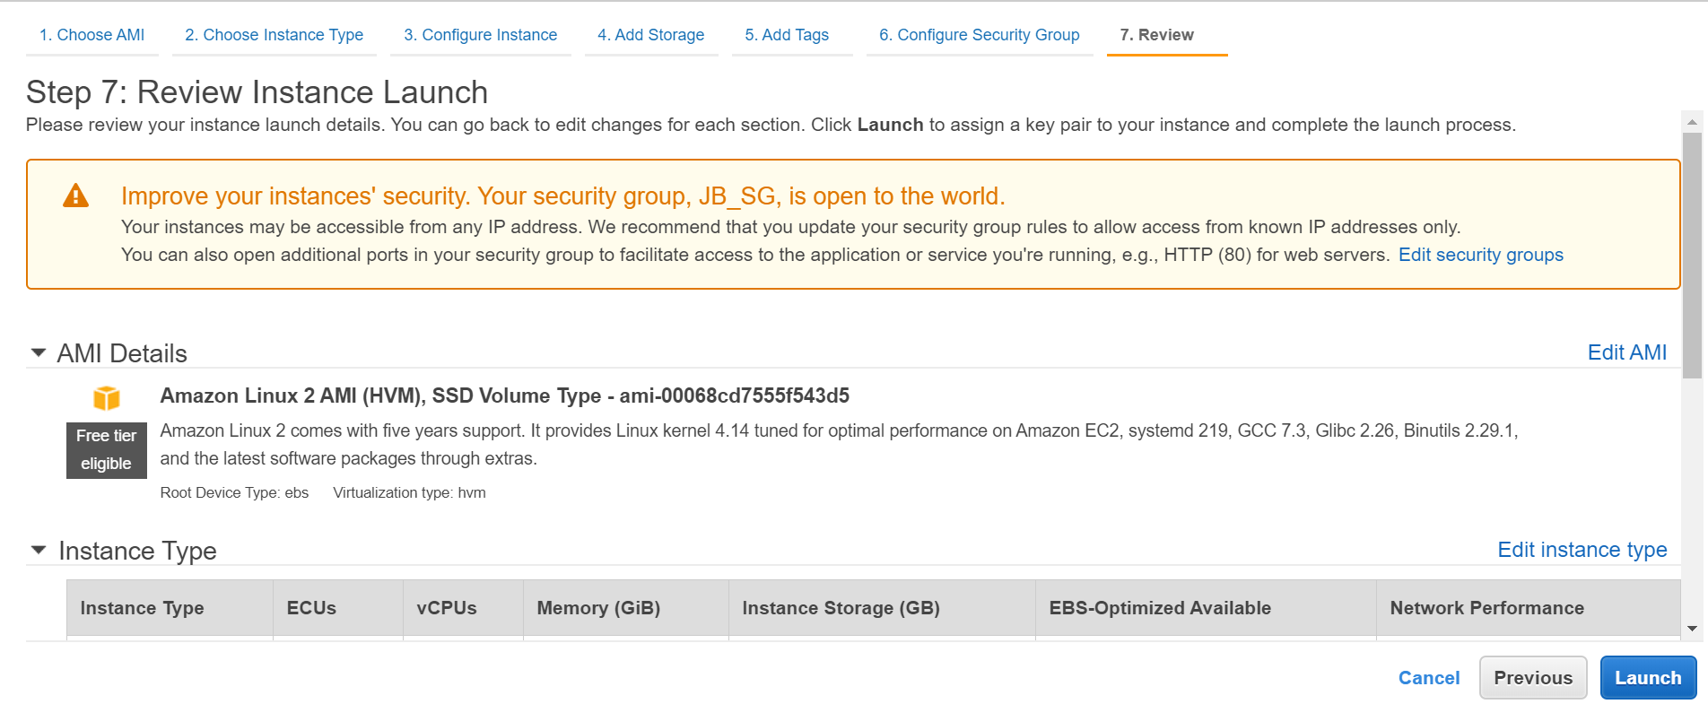

* Select **Create a new key pair** from the dropdown menu
* **Key pair name:** Eg. JB_KEYPAIR >> **Download Kay Pair**

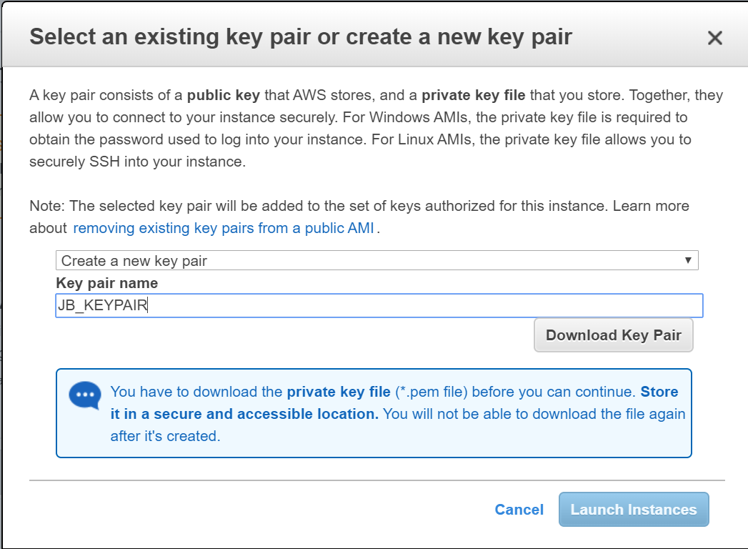

* Jumpbox instance has been created. Click on **View Instances** 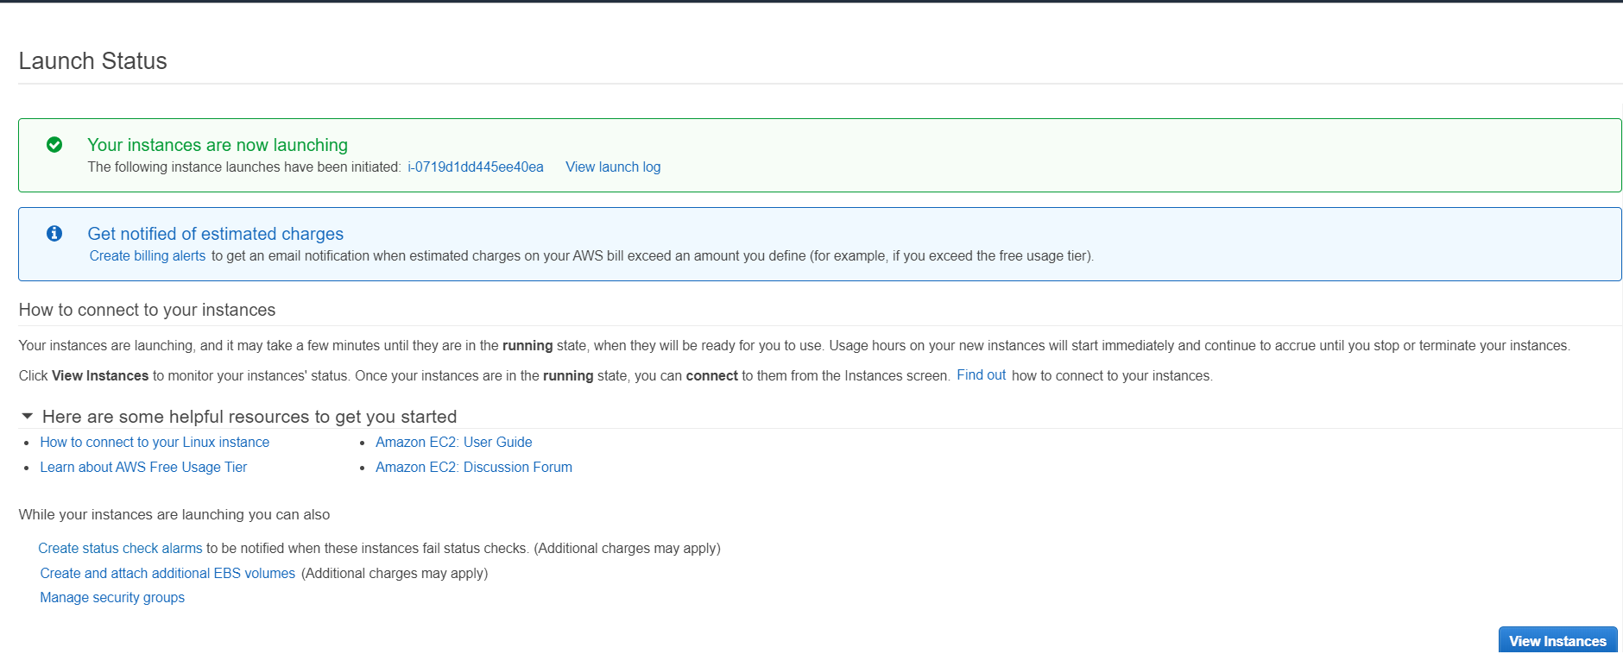
  1. **Creation of an EC 2 instance (say FI) in the Private Subnet**
* **‘console.aws.com’** >> **Services** >> **EC2**



* Click on **Launch Instance**



* Select the first **Amazon Linux 2 AMI** instance



* Select the second instance type **t.micro** >> **Configure Instance Details**



* **Network:** Select the correct VPC from the dropdown
* **Subnet:** Select the **Private subnet** from the dropdown
* Click on **Next:Add storage**

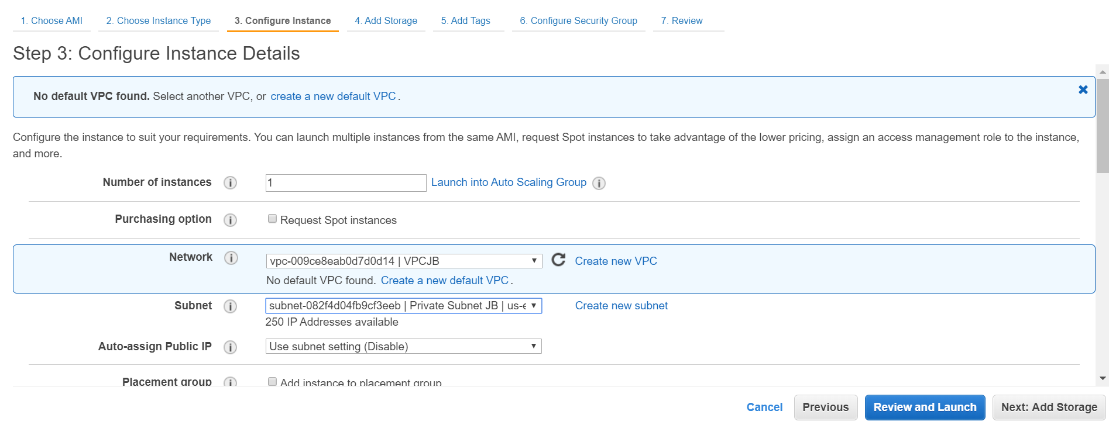

* Click on **Next:Add Tags**

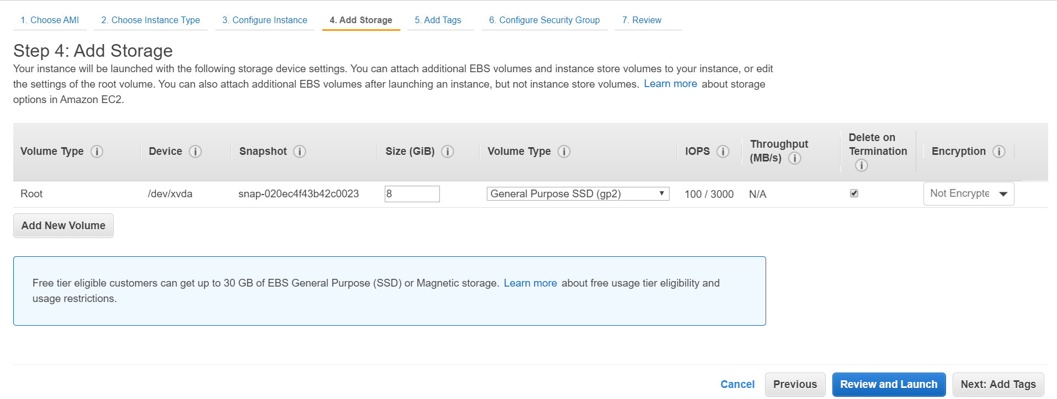

* Click on **Add Tag** >> **Key:** Name >> **Value:** Eg. FI >> **Next: Configure Security Group**

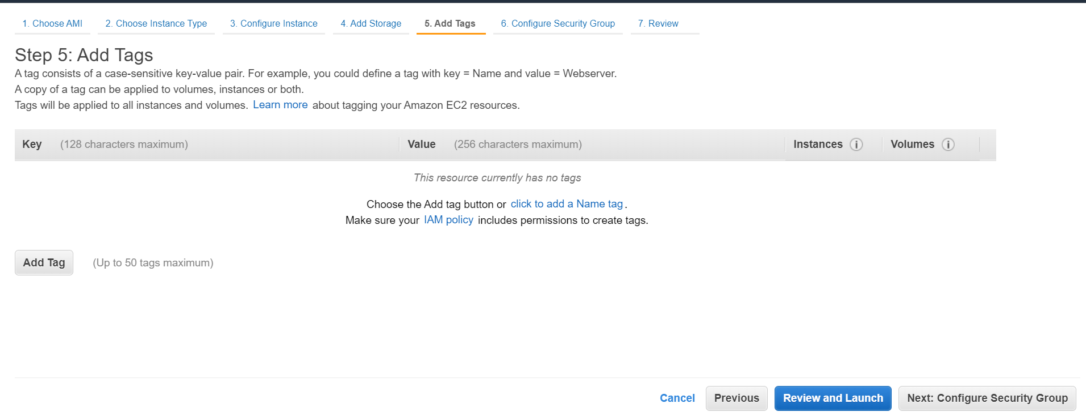

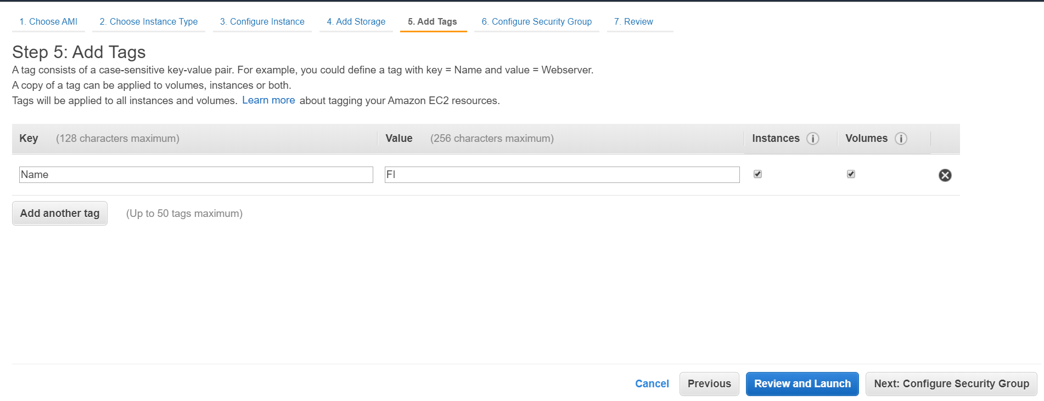

* Select **Create a new security group** >> **Security group name:** Eg. FI_SG >>
* **Description**: Eg.FI_SG >> **Review and Launch**

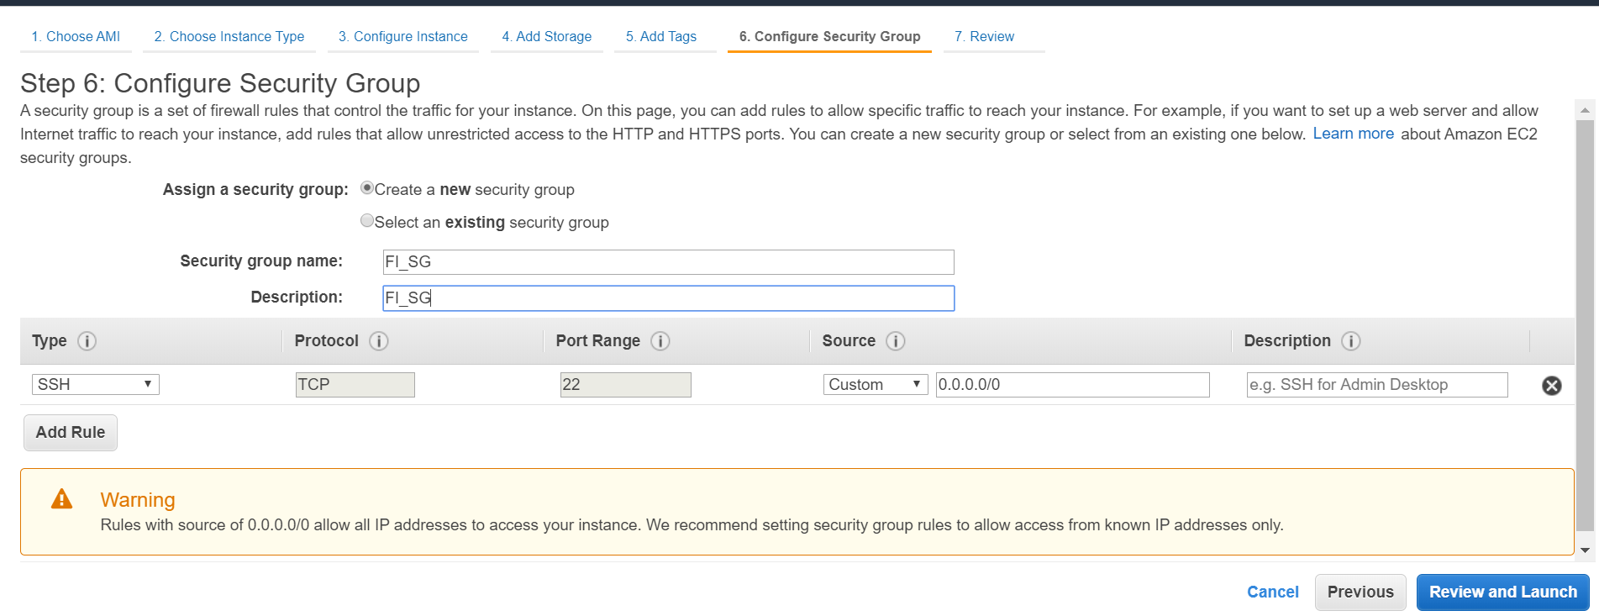

* Click on **Launch**

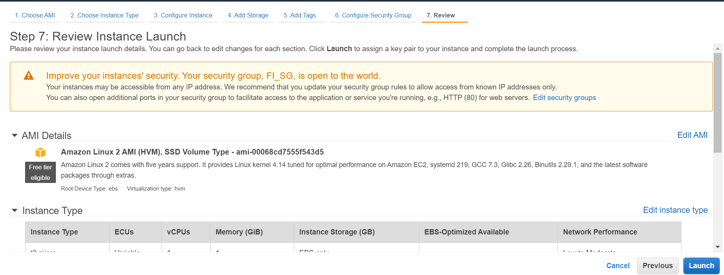

* Select **Choose and existing key pair** >> **JB_KEYPAIR** (your jumpbox key pair) >>

**Launch Instances** and a new instance is created in the Private subnet

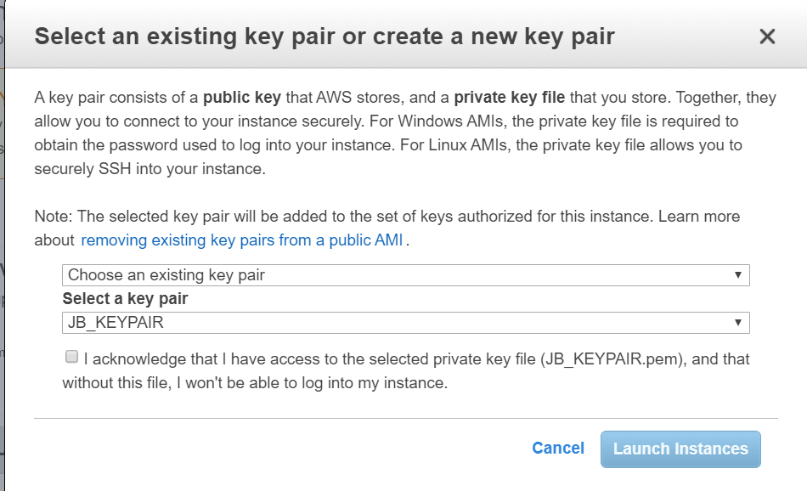

* **VPC Dashboard** >> **Route Tables** >> **Create route table**

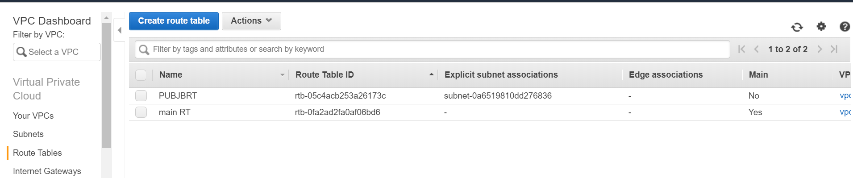

* **Name tag:** Eg.PVTJBRT >> **VPC**: Select the required VPC from the dropdown menu >> **Create**

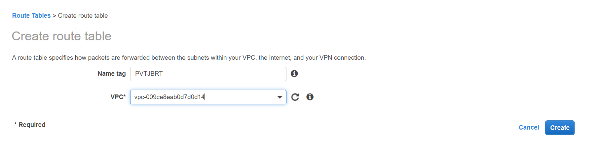

* The route table for the Private subnet is created >> **Close**

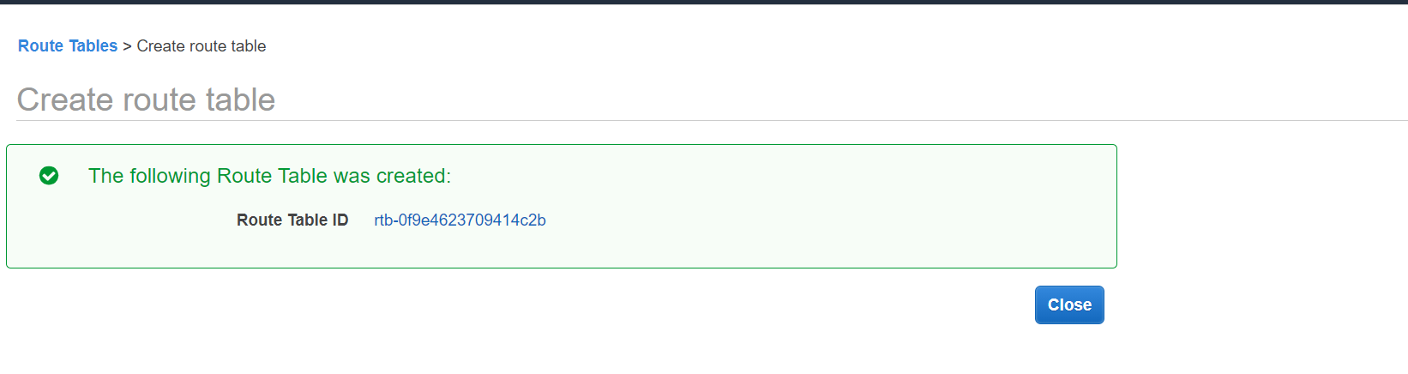

**Route tables** >> Select the newly created **Private route table** >> **Routes** >> **Edit routes**

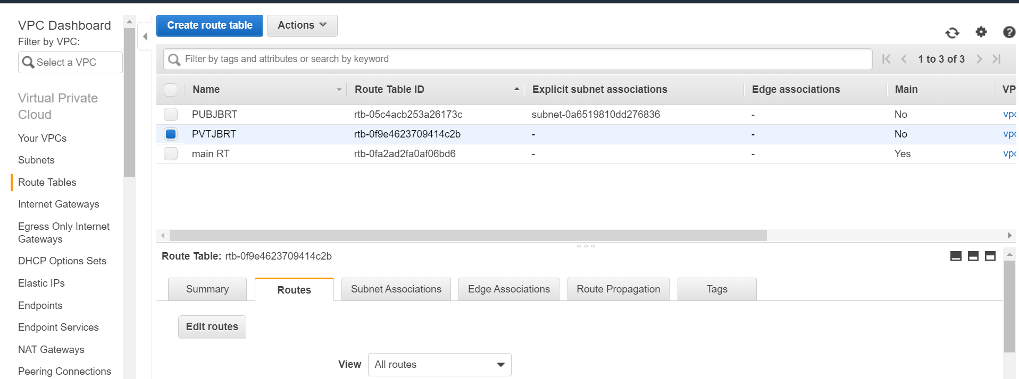

* **Add Route** >> **Destination:** 0.0.0.0/0 >> **Target:** Select **Instance** from the dropdown and select the **NAT instance** >> **Save routes.** Route is edited >> **Close**

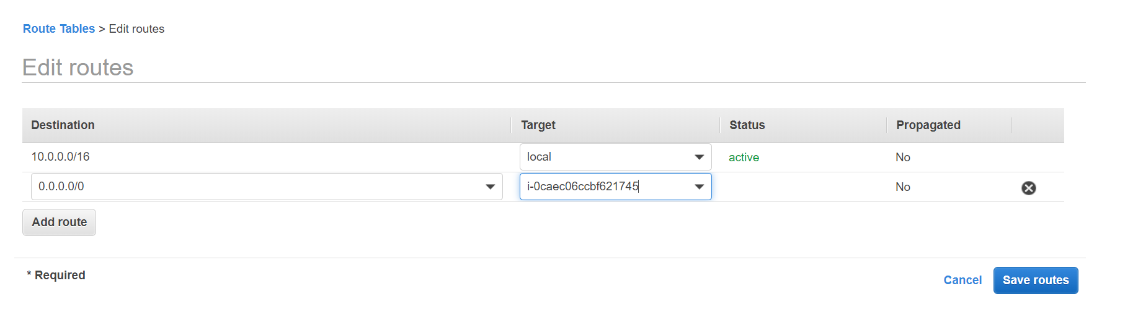

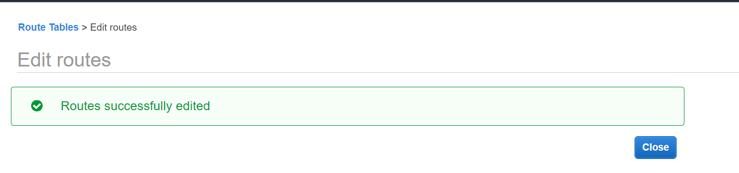

* **Subnets** >> Select **Private Subnet** >> **Route Table** >> **Edit route table association**

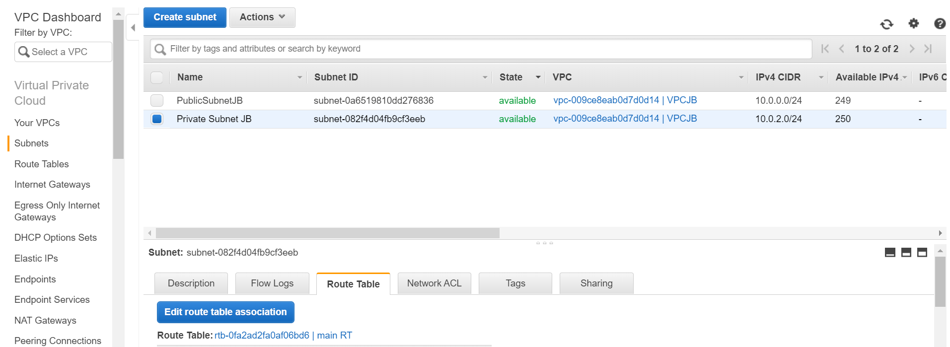

* **Subnet ID:** Select the Private Subnet ID >> **Route Table ID** >> Select the Private Route table ID from the dropdown menu >> **Save >>** Route tableassociation for theprivate subnet is edited >> **Close**

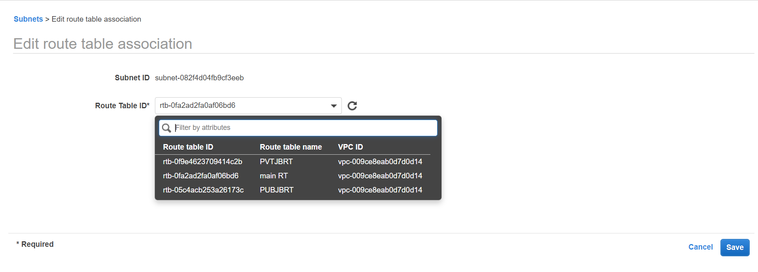

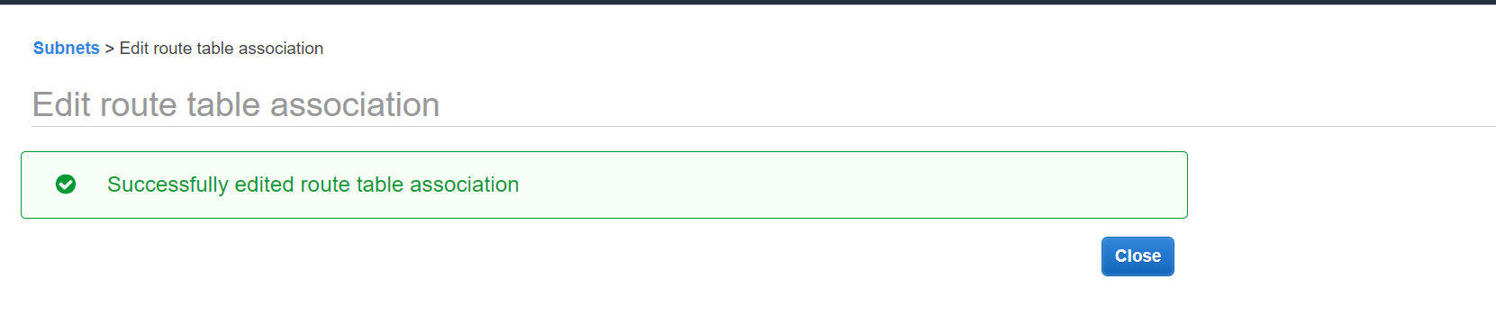

## **CREATING/EDITING SECURITY GROUPS**

**Instances** >> Select the **instance connected to the Private Subnet**, say FI, >> Click on the **Security group**, say, FI_SG

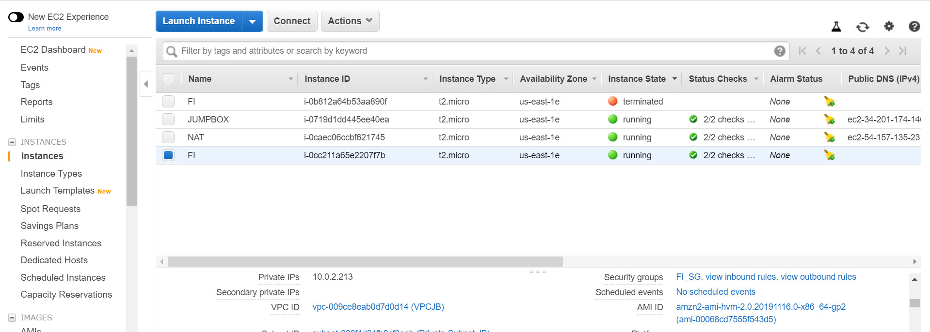

* Click on **Inbound** rules >> **Edit**

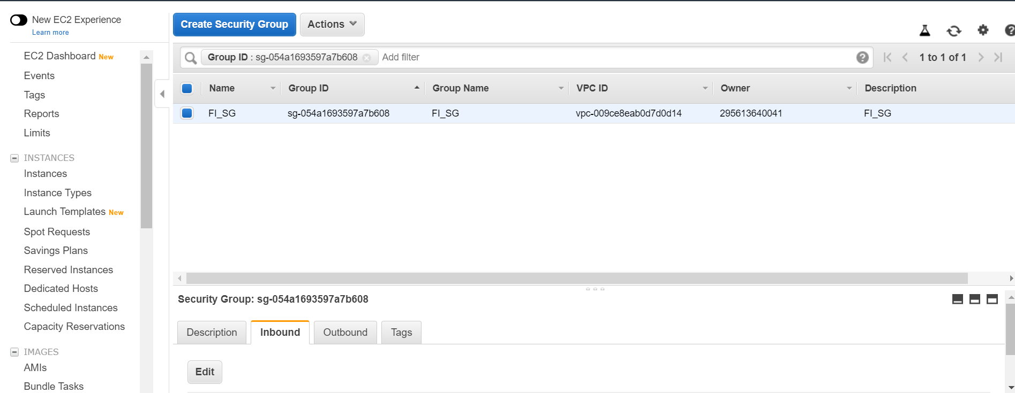

* **Source:** Type Sg and select **the security group of the jumpbox** from the dropdown menu >> **Save**

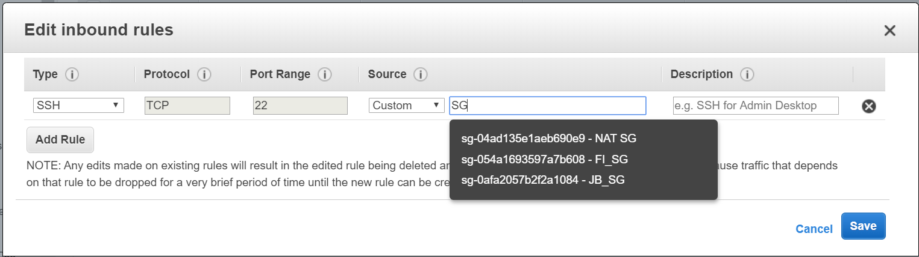

* **Instances** >> **NAT instance** >> **NAT SG**

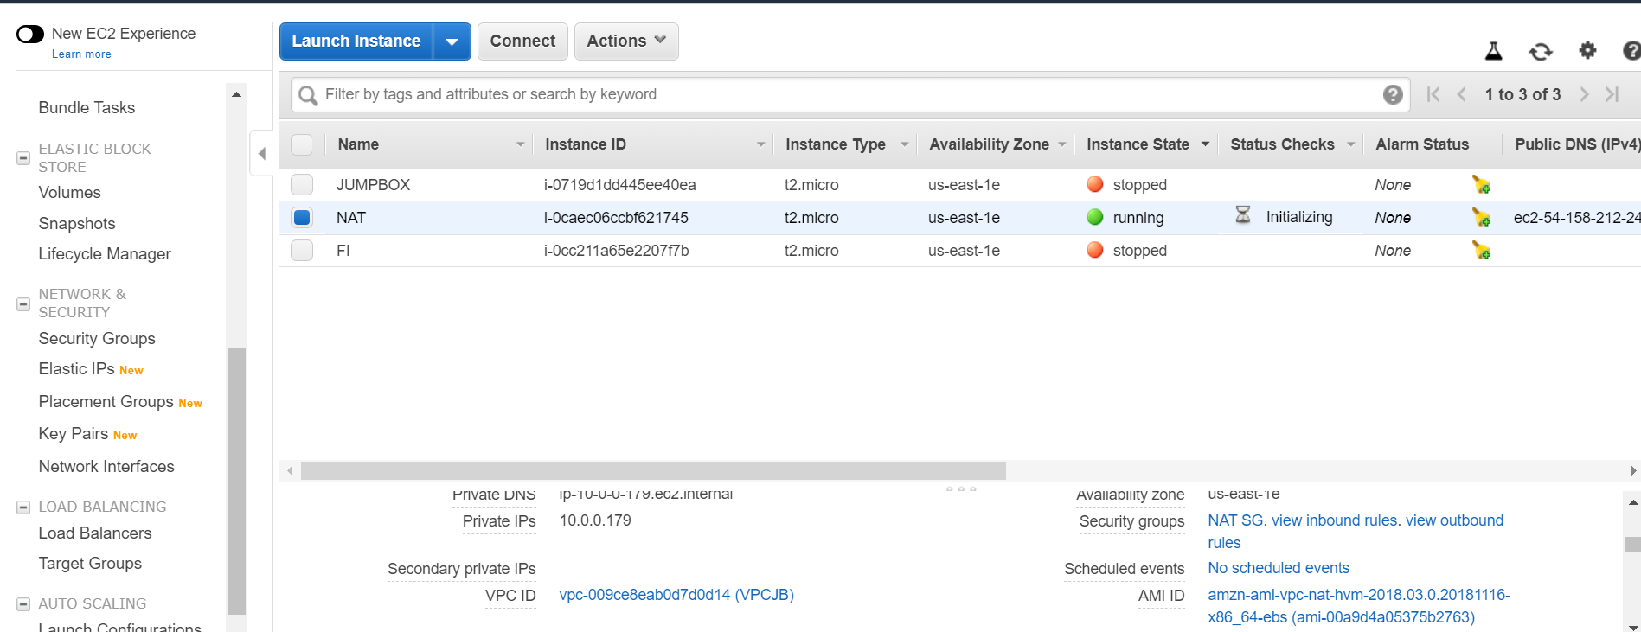

* Click on **Inbound** rules >> **Edit**

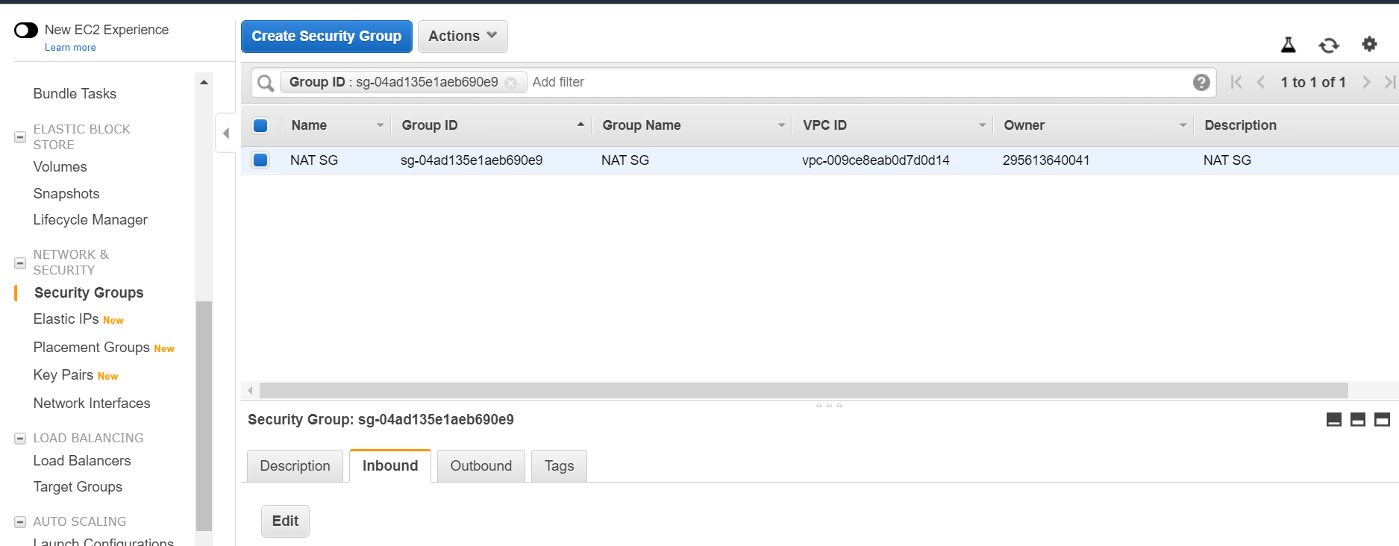

* **Type:** All traffic >> **Source:** Type Sg and select **the security group of the Final Instance (FI)** from the dropdown menu >> **Save**

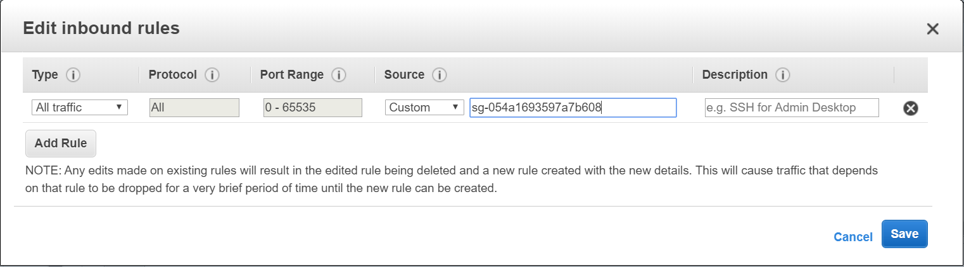

* **NAT Instance** >> **Networking >> Change Source/Dest. Check >> Yes, Disable**

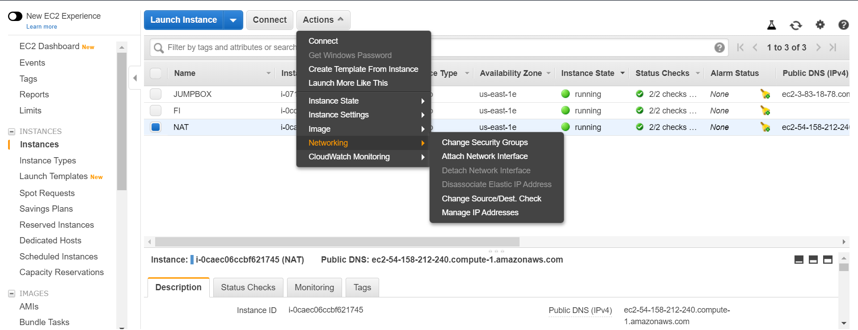

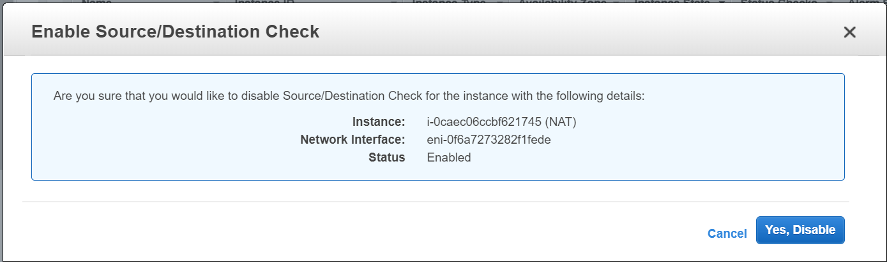

## **COPYING THE PRIVATE KEY TO THE JUMPBOX INSTANCE AND CONNECTING TO JUMPBOX IN THE PUBLIC SUBNET AND FINAL INSTANCE IN THE PRIVATE SUBNET**

* Copy the Private key pair, say, ‘JB_ JB_KEYPAIR.pem’ to the Jumpbox instance by typing the command in the windows command prompt as shown in the example below:

**scp -i JB_KEYPAIR.pem JB_KEYPAIR.pem ec2-user@ec2-3-83-18-78.compute-1.amazonaws.com:JB_KEYPAIR.pem** (Use your filepath, key pair file name and the public ip address of your jumpbox instance)

* Connect to the jumpbox instance by typing the command in the windows command prompt as shown in the example below:

**ssh -i "JB_KEYPAIR.pem" ec2-user@ec2-3-83-18-78.compute-1.amazonaws.com** (Use your key pair file name and the public ip address of your jumpbox instance)

* Change the permission of the key pair file by typing the command in the windows command prompt as shown in the example below:

**chmod 400** **JB_KEYPAIR.pem** (Use your key pair file name)

* Connect to the Final instance (say, FI) by typing the command in the windows command prompt as shown in the example below:

**ssh -i "JB_KEYPAIR.pem" ec2-user@10.0.2.213**

